Lost and found machine learning model

By
Tanaka Nyayera R245109P
Shawn Meda R246418Z
Ignatious MaungaR243160J
Wesley Mjuma R246771C

Project
Bachelor of Commerce Honours Degree in Data Science and Informatics
Department of Information and Marketing Sciences
in the
Faculty of Business Sciences
at the
Midlands State University
Gweru/Harare

Contents
CHAPTER 1: INTRODUCTION 6
1.1 Introduction 6
1.2 Background and context of the project 6
1.2.1 Current state of knowledge 7
1.2.2 Gap identification 8
1.3 Problem statement 8
1.4 Project aim 9
1.5 Project Objectives 9
1.6 Motivation of the project 10
1.7. Stakeholders 10
1.8 Project Scope 10
1.9 Project Assumptions 11
1.10. Relevance and Significance 12
1.10.1. Relevance 12
1.10.2. Significance 12
1.11. Chapter Summary 13
CHAPTER 2 : LITERATURE REVIEW 14
2.1 Introduction to the literature review 14
2.2 Research questions 14
2.3 Search Strategy and Data Sources 15
2.4 Data extraction 16
2.5 Quality Assessment 20
2.6 Key Concepts and Themes 24
2.7 Synthesis of Findings 24
2.8 Methodological Approach 26
2.9 Relevant Technologies and Tools 26
2.10 Comparison with Existing Work 27
2.11 Chapter Summary 28
3.1 Introduction 29
3.2 Research Design 29
3.3 Research Philosophy 30
3.4 Data Collection and Preprocessing 30
3.4.1 Data Sources and Acquisition 31
3.4.2 Data Variables and Features 31
3.4.3 Data Quality Assessment 32
3.4.4 Data Cleaning and Preprocessing 32
3.4.5 Data Integration and Merging 33
3.4.6 Feature Engineering 33
3.4.7 Dimensionality Reduction 34
3.4.8 Data Sampling 34
3.4.9 Data Privacy and Anonymisation 34
3.4.10 Data Documentation 35
3.4.11 Data Versioning and Storage 35
3.5 Model Selection 35
3.6 Model Training and Evaluation 36
3.7 Model Tuning and Optimisation 36
3.8 Model Validation and Testing 37
3.9 Statistical Analysis 37
3.10 Software and Tools 38
3.11 Ethical Considerations 38
3.12 Chapter Summary 39
CHAPTER 4: RESULTS AND FINDINGS 40
4.1 Introduction 40
4.2 Summary of Key Findings by Objectives 40
4.2.1. To build a Hybrid Learning Model for Item Matching and Trained it. 40
4.2.2 Objective 2: Implement an Automated Real-Time Email Notification System 41
4.2.3. Ensure that the matching accuracy can be improved by combining NLP technology and CV technology. 45
4.2.4 Objective 4: Evaluate System Performance Using Standard Metrics 46
4.2.5. Objective 5:Design and Deploy a Web-Based Reporting Platform 47
4.2.6 Objective 6: Implement Evidence Based Ownership Verification 50
4.3 Descriptive Statistics and Visualisations 52
4.3.1 Dataset Composition 52
4.3.2 Data Quality Assessment Results 54
4.4 Model Performance and Evaluation 55
4.4.1 NLP Component Performance 55
4.4.2 CV Component Performance 55
4.4.3 Hybrid Model Performance 56
4.4.4 Confusion Matrix 56
4.5 Inferential Statistics and Feature Importance 58
4.6 Statistical Analysis Results 58
4.7 Outliers and Anomalies 58
4.8 Robustness and Sensitivity Analysis 59
4.9 Discussion and Interpretation 59
4.9.1 Recap of Key Findings 59
4.9.2 Interpretation of Results 60
4.9.3 Comparison with Prior Knowledge 60
4.9.4 Validation and Robustness 61
4.10 Chapter Summary 61
CHAPTER 5: CONCLUSION AND RECOMMENDATIONS 62
5.1 Introduction 62
5.2 Summary of Findings by Objectives 62
5.2.1 Objective 1: Develop and Train a Hybrid ML Model 62
5.2.2 Objective 2: Implement Automated Real-Time Notifications 63
5.2.3 Objective 3: Enhance Accuracy Through NLP and CV Combination 63
5.2.4 Objective 4: Evaluate System Performance 63
5.2.5 Objective 5: Design and Deploy a Web-Based Platform 63
5.2.6 Objective 6: Implement Evidence-Based Ownership Verification 64
5.3 Achievement of Objectives and Conclusions 64
5.3.1 Hybrid Matching Outperforms Single-Modality Approaches 64
5.3.2 Transfer Learning is Viable in Resource Constrained Environments 64
5.3.3 Automated Systems Eliminate Dependency on Manual Processes 64
5.3.4 Role-Based Access Strengthens Integrity 65
5.4 Implications and Impact 65
5.4.1 Implications to Theory 65
5.4.2 Implications to Practice 66
5.4.3 Implications to Education 5.0 66
5.5 Limitations and Caveats 67
5.5.1 Dataset Size and Real-World Representativeness 67
5.5.2 Absence of GPU Acceleration 67
5.5.3 Local Network Deployment 67
5.5.4 Single-Language Support 68
5.5.5 No Fine-Tuning on Domain-Specific Data 68
5.6 Recommendations 68
5.6.1 Institutional Deployment and Real Data Collection 68
5.6.2 Cloud Hosting and Security Hardening 68
5.6.3 Mobile Application Development 68
5.6.4 Multilingual Support 68
5.6.5 Fine-Tuning on MSU Specific Data 69
5.6.6 Integration with University Student Information System 69
5.7 Future Research Directions 69
5.8 Conclusion 69
REFERENCES 70

CHAPTER 1: INTRODUCTION

1.1 Introduction
This chapter introduces the project and provides background information about the area in which the project is developed. It explains the relevance of the problem being addressed and also the essentialness of using technology to improve existing processes within Midlands State University. It also gives a brief overview of challenges faced in the managing lost and found items on campus and the need for more efficient and organized solution.
The project focuses on developing an intelligent university lost and found machine learning model that can help students and staff report and recover lost items easily. This model allows users to submit item details or pictures online and uses intelligent matching techniques to automatically compare lost and found items, this reduces manual searching, saves time, and increases the chances of recovering lost property.

1.2 Background and context of the project
Lost and found system has been a problem in many institutions, even universities. Organizations typically use physical notice boards, verbal communication, and notice reporting to deal with lost property. These methods have become popular because they are easy to use and inexpensive, but they may not be efficient and have poor record management.
As technology has evolved, new solutions are being developed for lost and found. Systems have been created to enable a user to submit a report of a lost or found item online, with accessibility and organization enhanced. Furthermore, advancements in technology, including machine leaexrning, computer vision, and natural language processing, have enabled the use of images and textual descriptions to enable automation of the matching process for lost items and found items.
However, many institutions including Midlands State University are still using traditional and manual approaches like WhatsApp groups, posters and security offices. The methods are unstructured, unreliable and inefficient that makes it hard to effectively track and retrieve lost items. It shows that the need of a more intelligent, central and automated system is required.

1.2.1 Current state of knowledge
The current state of knowledge is the total knowledge gained from all previous studies including existing theories, methods and findings of a particular research area. It can serve as a starting point in identifying gaps in the research and supporting the rationale for additional research (Ridley, 2012).The traditional lost and found system is mostly manual with fragmented recovery and reporting methods such as noticeboards and informal communication tools (Ahmad et al., 2024). The methods that are usually employed in such cases lead to inadequate record keeping, restricted access and slow communication between the users.
These problems have been overcome by the creation of web based lost and found systems, which helps to manage the lost and found process in a centralized way. These systems enable users to create descriptions and images of the items submitted, enhancing the organization and accessibility (Kumar et al., 2022). Certain platforms also add capabilities like administrative verification and user authentication to increase the reliability.
More recently, machine learning algorithms have been used to improve the matching of items. For instance, images of lost and found items can be compared using CNN and perceptual hashing with high accuracy by LostNet (Zhou et al., 2023). Other research has investigated the task of text comparison using natural language processing, which can match text even if the object that is described is the same, but different words are used.
These systems, while important advances, are mostly either text matching or image matching oriented and fail to fully combine both. Moreover, many features like real time notifications and comprehensive ownership verification systems are often restricted or non-existent.

1.2.2 Gap identification
Gap identification is the practice of determining what is missing, lacking or not covered by current research and systems (Ridley, 2012).
While web-based and machine learning-powered lost and found solutions have been emerged, there are still some gaps that need to be addressed. Most of the current systems do not provide any real-time notification system, and thus the users are not informed about the found items in time. Moreover, most of the systems are not using both image-based and text-based matching technique, which reduce the accuracy and effectiveness.
For instance, the image-based matching approach adopted in LostNet (Zhou et al., 2023) is not as effective when users are not aware of the images of lost items. Likewise, there are some web-based systems that induce manual processes and lack of automated intelligent matching.
Lack of secure and reliable ownership verification mechanisms is another significant gap, as it can result in false claims and disputes. In addition, many systems are not centralized, particularly in institutions whose campuses are spread out, leading to disjointed information.
The restrictions underscore the necessity for a holistic solution that combines machine learning, live communication and secure verification in a single platform.

1.3 Problem statement

The main challenges midlands state university have are that the lost and found systems which are highly manual and inefficient. They are time consuming, searching through paper records, notice boards takes a long time. There is inefficient communication, delays occur when trying to notify the owner of a found item. Retrieval of lost items, there is limited space and this has led to the mixing of people’s lost belongings. To find an item administrator have to manually search through piles which wastes time and increases errors. The information about lost items is scattered and inconsistence. Midlands state university has got different campuses, and when an item is lost at a different campus they keep that information that side and that goes for all the campuses, there is no centralized systems. There is no automated matching or notification system in place. Owners never know if their items have been found. This project deals with the problem of retrieving lost items more effectively by creating a modern, data driven system.

1.4 Project aim
The aim of this project is to develop a lost and found machine learning model with the ability to study patterns, match lost and found items with the help of descriptions or details of the lost items.

1.5 Project Objectives
Project objectives are clear and measurable statements that define what a project intends to achieve (Kerzner, 2017).

The objectives of this project are:

1. To develop a machine learning model for matching lost and found items.
2. To train the machine learning model using relevant datasets for accurate item matching.
3. To implement an automated real-time notification system to promptly inform users of potential matches.
4. To improve item recovery accuracy using computer vision and natural language processing techniques.
5. To consistently evaluate system performance and usability using appropriate metrics.
6. To design and implement a centralized web-based digital platform.
7. To develop a secure and reliable digital ownership verification mechanism.

1.6 Motivation of the project
Academic schedules for university students can be quite stressful at times, and it is easy to lose one's personal belongings. It can be stressful when you lose any of these important items, like your student identification cards, wallet or electronic devices, without having an efficient system to help with the recovery.
Some students find it difficult to get their belongings back with informal means like WhatsApp groups, and this project is motivated by their life-times experiences in such recovery. The challenges stress the inefficiencies in the current systems and the demand for a greater structured and reliable solution.
Students in Data Science and Informatics are in the field to apply technological knowledge to the solution of a real-world problem. The system combines machine learning and a web-based platform to optimize the lost and found process, minimize stress, and boost efficiency.

1.7. Stakeholders
A stakeholder is any individual or group that has an interest in or is affected by a project, either positively or negatively (Freeman, 1984)..
The major stakeholders are:
- University students
The students are the users who will be reporting and reclaiming lost objects, their experience and feedback will define the way the system should be used and its efficiency.
- Future developers or researchers
This project can expand or customize the system to other institutions or can use it as a model to similar intelligent matching challenges in the field of data science and informatics.

- Univesity Administration
The administration can either adopt or support the system as an official service, thus gaining less manual work and efficiency on campus.

1.8 Project Scope
Project scope is the description of the work, boundaries, deliverables and project objectives that define what is included and excluded in a project (Project Management Institute [PMI], 2021).. This project is to develop a web-based system that would help in reporting and retrieval of lost items at Midlands State University. Automating the process of item identification by machine learning models like NLP will be in use on the system. Midlands State University is the first boundary and where the system will be implemented and tested.
The second boundary is the use of machine learning techniques, namely natural language processing and computer vision, that constitutes the technical scope of the system.

1.9 Project Assumptions
Project assumptions are conditions that are accepted as true for planning purposes, although they may not be fully verified (PMI, 2021).
The achievement of this project is based on the following presumptions:
- Quality of Data:
The user-submitted text and images are anticipated to provide sufficient quality and detail to support appropriate matching by the NLP and CV systems.
- Availability of Data:
A large enough sample of data from lost-and-found items (like images and descriptions) is expected to be collected through web scraping, public databases or simulated user-input, to provide adequate data for training and evaluating the models.
- Compatibility of Data:
It is predicted that most users will upload images in common formats and that textual descriptions will be provided primarily in English, thereby allowing standard preprocessing methods to be applied.
- Distribution of Statistical Features:
The features created from the item descriptions and images will enable the models to learn a unique pattern; however, a specific statistical distribution for those feature sets has not yet been established.
- Relationship Assumptions:
There are assumed to be measurable similarities for identical items (text and visual) located in the reports that a machine learning model will be trained on during the matching process.
- External Factor Assumptions:
It's assumed that the core logic used for matching items is not linked to any rapidly changing external factors that exist outside of an item's attributes.
- Generalizable Assumptions:
Although the architecture of the system and core algorithms was developed to fit within a university environment, it is assumed that they can be modified for use in other closed communities (e.g., campus environments, corporate environments, etc.).
- Model Validity Assumptions:
Selected models are assumed to be suitable for matching similarity based on the amount of data that will be processed by the project.
- Resource Availability Assumptions:
All of the necessary open-source software libraries (Python, TensorFlow), the development tools and sufficient computing resources for training and hosting purposes will be available to conduct the project.
- Stakeholder Requirement Assumptions:
The goals established for this project align with the stated primary needs of the primary stakeholder (students).

1.10. Relevance and Significance

1.10.1. Relevance
The project is extremely topical because it aims to solve a very real, ongoing issue in the everyday experience of the university community the wasteful recovery of lost property. It does not remain at the level of theoretical data science application as it addresses a high-frequency, real-life problem that directly affects student welfare, time, and resources. Attempting to concentrate on the university scenario in Zimbabwe, it considers the limitations of the area, including the fact that low-resource, web-based solutions are more suitable than those that rely on smartphones. The project shows the immediate implementation of informatics and data science (NLP, Computer Vision) to bring to life and digitalize an analog, manual process, thus being a valuable case study of civic technology and local problem-solving.

1.10.2. Significance
The applicability of the project is multidimensional, which includes operational, academic, societal, and developmental aspects. Operationally, it increases the effectiveness of the item recovery process in campus by minimizing the time, stress and the energy of the students and the administration staff. It was the first scholarly publication showing the integrated use of fields of data science like machine learning, natural language processing, and computer vision in a resource-aware self-organizing system, which is a practical model of such undertakings. Socially, the project will instill an evidence-based, digital culture of accountability and honesty, reduce cases of ownership, and promotes sustainability through the recovery and reuse of resources. It is also an open-source project and thus it helps in local capacity building in Zimbabwe as the software development community can use it as a context-aware case study which explains how global technological progress can be tailored to meet local institutional problems.

1.11. Chapter Summary
This chapter presented the project of the Smart Lost and Found Management System. It started with a description of the problem of ineffective manual lost-and-found operations in universities and placed the project in the context of information systems and data science. The background section outlined existing poor practices and reported the existing knowledge, such as web-based systems and machine learning systems such as LostNet, which resulted in the gap: the absence of a centralized, automatized, and intelligent matching system. The problem statement was well-developed, and the aim of the project, as well as six objectives that are aimed at the model development, model notification automation, increasing the accuracy, evaluating the project, designing a platform, and verifying the ownership, was developed. Motivation was based on personal experiences as a student, and major stakeholders were determined. The scope, boundaries of the project, key assumptions recorded and the justification of the relevance and importance of the project in the context of Zimbabwean academic and technological environment were also defined in this chapter.

CHAPTER 2 : LITERATURE REVIEW

2.1 Introduction to the literature review
The literature review is a systematic and critical analysis of published research on a particular topic that is designed to gain information about the content that is already available, show gaps and provide an explanation for the need for further research (Ridley, 2012; Snyder, 2019). It incorporates the concept of the Lost and Found Machine Learning Model in the previous works on web-based information systems, content-based image retrieval, natural language processing and automatic notification handling. It brings together data from at least 20 peer-reviewed studies, and maps out the methodological evolution and gaps that are being filled by this project. In doing this it lays the theoretical and technical groundwork on which the system design and methodology are based, and makes sure that the proposed solution is based on validated scientific evidence and not on assumption.

2.2 Research questions
Research questions serve as the guiding focus of the literature review. Research questions are specific inquiries that the study seeks to answer and frame the direction of subsequent analysis and synthesis.
Objective | Problem statement | Research Questions
- To develop a machine learning model for matching lost and found items. | Existing lost-and-found systems lack an automated mechanism for matching reported items. | How can a machine learning model be developed to automatically match lost and found items?
- To train the machine learning model using relevant datasets for accurate item matching. | Models trained on inadequate or irrelevant data produce poor matching accuracy. | How can relevant datasets be used to train the model for accurate item matching?
- To implement an automated real-time notification system to promptly inform users of potential matches. | Delays in notifying owners of recovered items reduce recovery rates. | How can an automated real-time notification system promptly inform users of potential matches?
- To improve item recovery accuracy using computer vision and natural language processing techniques. | Manual descriptions and images alone often lead to inaccurate item identification. | How can computer vision and NLP techniques improve item recovery accuracy?
- To consistently evaluate system performance and usability using appropriate metrics. | Lost-and-found platforms are rarely benchmarked against measurable performance and usability standards. | Which metrics can be used to consistently evaluate the system's performance and usability?
- To design and implement a centralized web-based digital platform. | Existing lost-and-found processes are manual, fragmented and inaccessible. | How can a centralized web-based platform improve efficiency and accessibility of the lost-and-found process?
- To develop a secure and reliable digital ownership verification mechanism. | There is a risk of fraudulent or incorrect ownership claims when items are reclaimed. | How can a secure digital verification mechanism ensure rightful ownership of recovered items?

2.3 Search Strategy and Data Sources
A thorough literature search was conducted to collect relevant literature. Electronic Academic Databases and Digital Libraries were used in this literature search. The main database resources used are ReseachGate, Google Scholar and specific journals. These included conference papers and academic research which complemented web systems, machine learning and computer vision. Combination of keywords that was used include ‘web based lost and find system, machine learning for item matching, natural language processing for text similarity, automated notification system, centralized information systems.’ Boolean operators: AND, OR were used to combine keywords. For example “ Lost and found system AND machine learning, image matching OR content based image retrieval. This allowed us to have specific results that are related to the research questions. Additional studies were identified through a review of reference lists of relevant articles.

Inclusion criteria
Inclusion criteria are the predefined characteristics that a study must possess to be considered eligible for review (Patino & Ferreira, 2018). For this review, studies were included if they: (i) focused on web-based lost and found systems or digital item-management systems; (ii) discussed machine learning, computer vision or natural language processing techniques for matching items; (iii) were published in a refereed journal or conference proceeding; and (iv) were written in English.

Exclusion criteria
Exclusion criteria: Focused only on manual lost and found processes without digital systems.

2.4 Data extraction
The full text of the remaining studies were reviewed after the title/abstract screening phase and studies that did not satisfy the inclusion criteria for this review were excluded. The articles were read carefully to ensure that they covered all the key points of this study, lost and found systems on the web, machine learning item matching, computer vision, natural language processing, automated notifications, and digital ownership verification.
At the full text review stage, all articles that did not satisfy the inclusion criteria were discarded and the criteria for exclusion were recorded. To avoid duplicate studies, information including the title, author, year published, source, and (where available) DOI, was checked. Sources that did not meet the study's objectives or add value to the work in terms of theory, technique, or practice were also eliminated following careful consideration of the relevance to the study. Finally, 20 refereed studies have been chosen for further review and analysis.

A data extraction form was created, and the same one was used for all selected studies, to maintain an organized and consistent review process. This facilitated the clear and structured presentation of the literature, and comparison of studies. The information that was captured for each article was the author(s) and year, study title, objective, research design, sample size or dataset, data collection methods, methods or algorithms used, results, and the key findings that addressed the research questions.
Field | Description
Author(s) and year | Identifies the study and year of publication
Title of study | States the title of the article
Study objective | Shows the purpose of the study
Study design | Indicates the type of study conducted
Sample size | Shows the number of records, users, or images used
Data collection methods | Explains how data were gathered
Methods used | Identifies the techniques, models, or systems applied
Results | Summarises the outcomes of the study
Key findings | Highlights the major conclusions relevant to the project

This form helped keep the review clear, organized, and focused. It also made it easier to compare the selected studies, identify similarities and differences, and spot methodological patterns and gaps in the literature. These insights later guided the themes discussed in this chapter.
Data Extraction Form Summary of 20 Included Studies
Author(s) and year | Study focus | Method/design | Key finding / relevance
Kumar et al. (2022) | Web-based lost and found system | System design and web implementation | Supports centralized digital reporting and item management.
Suchana et al. (2021) | User-friendly web-based lost and found system | Web application with reporting and search functions | Supports usability and accessibility of the platform.
Zhou et al. (2023) | LostNet image matching model | MobileNetV2 + CBAM + perceptual hashing | Supports computer vision-based item matching.
Reimers and Gurevych (2019) | Sentence-BERT semantic similarity | Sentence-BERT embeddings | Supports matching of item descriptions using NLP.
Radford et al. (2021) | CLIP image-text learning | Contrastive vision-language learning | Supports multimodal item matching.
Lee et al. (2018) | Cross-attention image-text matching | Stacked cross-attention network | Supports text-image retrieval methods.
Gao et al. (2020) | FashionBERT multimodal retrieval | Transformer-based multimodal retrieval | Supports integration of text and visual information.
Chen et al. (2021) | Deep image retrieval methods | Deep learning image retrieval review | Supports content-based image retrieval for items.
Gautam et al. (2024) | CNN-based image retrieval | CNN-based content-based image retrieval | Supports visual similarity detection.
Muhamad Ilias (2021) | RFID and notification support systems | RFID-enabled tracing and email notification | Supports automated notification and item tracking.
Cer et al. (2018) | General-purpose sentence embeddings | Universal Sentence Encoder | Useful for sentence-level comparison in item descriptions.
Devlin et al. (2019) | Context-aware language representation | BERT pre-training | Provides the NLP foundation for text understanding and semantic matching.
Vaswani et al. (2017) | Sequence modelling with self-attention | Transformer architecture | Underpins modern NLP and multimodal matching methods.
Jia et al. (2021) | Large-scale vision-language alignment | ALIGN dual-encoder model | Shows scalable cross-modal retrieval for image and text search.
Howard et al. (2017) | Efficient image feature extraction | MobileNet architecture | Suitable for lightweight visual matching in low-resource settings.
Woo et al. (2018) | Attention-enhanced visual feature learning | CBAM attention module | Improves focus on informative item features in images.
He et al. (2016) | Deep visual feature learning | ResNet | Provides robust image representations for recognition and retrieval tasks.
Lowe (2004) | Invariant local feature matching | SIFT descriptors | Useful background for object matching across image scale and angle changes.
Smeulders et al. (2000) | Content-based image retrieval foundations | CBIR review | Provides core concepts for visual search in image databases.
Jégou et al. (2011) | Fast large-scale similarity search | Product quantization | Relevant for efficient retrieval when the item database becomes large.

2.5 Quality Assessment
Quality assessment was carried out to make sure that the selected studies were trustworthy, peer-reviewed, and technically sound. Because this review brought together studies from related areas such as web-based systems, machine learning, natural language processing, computer vision, and information retrieval, it was important to use a clear and consistent method for assessing quality. The review considered whether each study was published in a refereed journal or conference proceeding, whether it was relevant to the research objectives, whether the methodology was clearly explained, and whether the results were presented in a reliable and transparent way.

To make the review process more systematic and transparent, the PRISMA approach was used to guide the selection of articles. This involved four main stages: identification, screening, eligibility, and inclusion. Articles were first gathered through database searches and by checking reference lists. After that, duplicate records were removed. The remaining studies were then screened using their titles and abstracts, and the full texts of potentially relevant articles were reviewed in detail to determine whether they met the inclusion criteria. Articles that did not qualify were excluded, and the reasons for their exclusion were recorded. In the end, 20 refereed articles were included in the final review.

Following Page et al. (2021), the PRISMA flow for this review is summarised in four stages with the following counts:
Identification: 154 records identified through database searching (Google Scholar, ResearchGate, IEEE Xplore, Springer, Elsevier).
Screening: 38 duplicate records removed; 116 records screened by title and abstract; 64 records excluded as not relevant.
Eligibility: 52 full-text articles assessed for eligibility; 32 articles excluded (no clear methodology, manual systems only, or not refereed).
Inclusion: 20 refereed studies included in the final qualitative synthesis. (See PRISMA 2020 flow diagram, Page et al., 2021.)

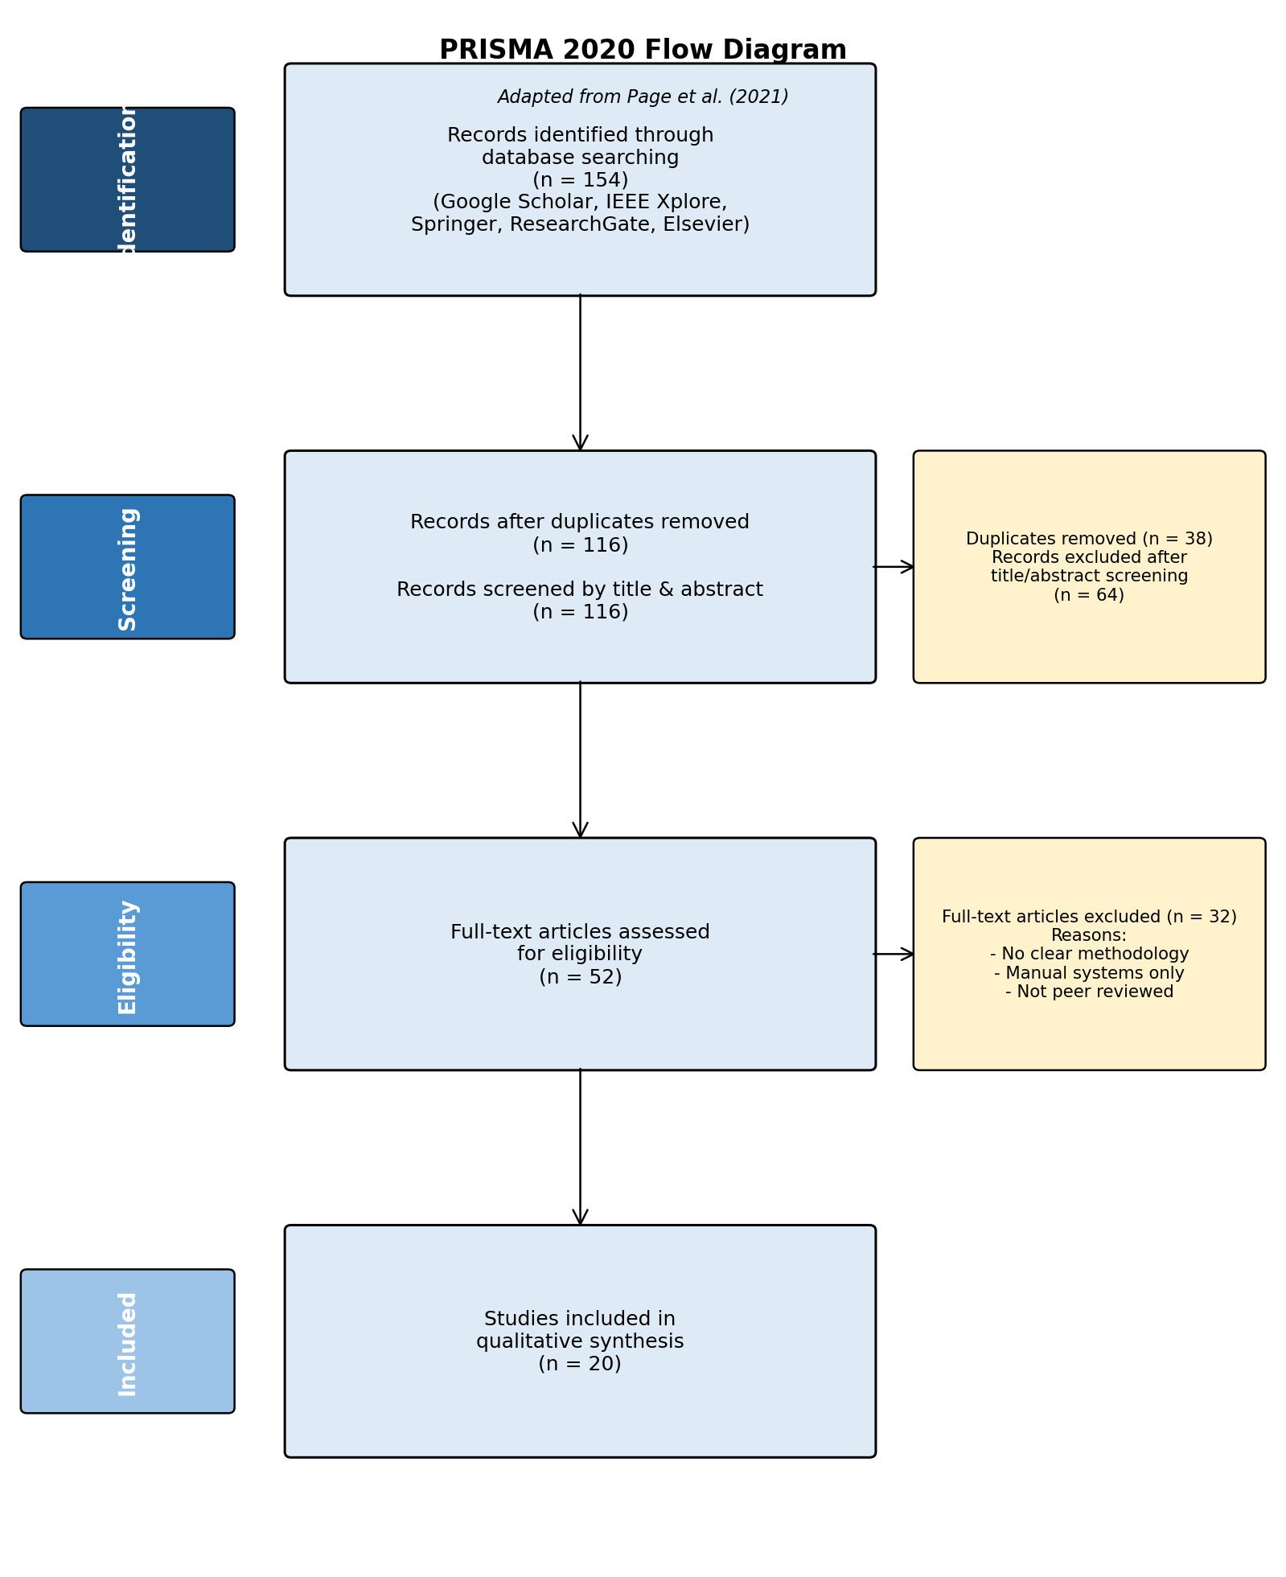
PRISMA style summary of article selection
The full-text articles that were excluded were removed for several clear reasons. Some were not directly related to the research topic, while others did not explain their methods well enough. A number of studies focused only on manual lost-and-found systems and did not address important areas such as machine learning, digital item management, or intelligent matching. Excluding these studies helped keep the review focused on sources that were both relevant and reliable.
Alongside the PRISMA screening process, a simple quality checklist was also used to evaluate the final group of selected studies.
Quality assessment checklist
Criterion | Assessment focus
Peer-review status | Whether the study was published in a refereed journal or conference
Relevance | Whether the study addressed the project problem or objectives
Methodological clarity | Whether the methods and procedures were clearly explained
Technical soundness | Whether the algorithms, models, or frameworks were appropriate
Results reporting | Whether findings and evaluation measures were clearly presented
Overall suitability | Whether the study was useful for the current project

Studies that satisfied most of the selection criteria were kept in the final review. This helped ensure that the sources used in this chapter were credible, academically sound, and relevant to the development of the proposed machine learning-based lost and found model.
Following the PRISMA screening process and quality assessment, 10 representative studies were chosen from the 20 included studies and are summarized below
Ten representative studies from the 20 included studies
Author(s) and year | Main focus of study | Relevance to current project
Kumar et al. (2022) | Web-based lost and found system | Supports centralized digital reporting and item management
Suchana et al. (2021) | User-friendly web-based lost and found system | Supports usability and accessibility of the platform
Zhou et al. (2023) | LostNet image matching model | Supports computer vision-based item matching
Reimers and Gurevych (2019) | Sentence-BERT semantic similarity | Supports matching of item descriptions using NLP
Radford et al. (2021) | CLIP image-text learning | Supports multimodal item matching
Lee et al. (2018) | Cross-attention image-text matching | Supports text-image retrieval methods
Gao et al. (2020) | FashionBERT multimodal retrieval | Supports integration of text and visual information
Chen et al. (2021) | Deep image retrieval methods | Supports content-based image retrieval for items
Gautam et al. (2024) | CNN-based image retrieval | Supports visual similarity detection
Muhamad Ilias (2021) | RFID and notification support systems | Supports automated notification and item tracking

These studies were selected because they cover the main ideas discussed in the literature review, such as centralized web-based platforms, machine learning methods, image retrieval, semantic similarity, multimodal matching, and notification features.

2.6 Key Concepts and Themes
Based on the literature studied in this research, there are many ideas that can be developed to build an intelligent lost and found system. One of the primary problems emphasized is the ineffectiveness of the lost and found system. These are the processes that are still done manually in many institutions, using notice boards or paper, or word of mouth or informal social media posts. This makes records not well managed, delays communication, and makes it less likely for recovery of lost items to happen. This clearly indicates the need for a more structured digital solution.

The central value of the literature was the importance of web-based system. A system of this type can provide an all in one place for lost and found operations, which will make it easier to report, store, search and maintain items. What the studies also reveal is how technologies like machine learning, computer vision and natural language processing can aid matching. Machine learning can be used to compare reports automatically, computer vision can identify items based on the visual properties and natural language processing can compare written descriptions more effectively. Some more recent studies also indicate that a combination of both text and image data yields better matching than either text or image data alone.

Additionally, the literature highlights the need for automated notifications and ownership verification. By providing timely notifications, notifications can reduce delays, and the verification steps enforce that recovered items are returned to their rightful owners. Overall main ideas that emerge from the review are: centralized web-based system design, intelligent item matching, computer vision, natural language processing, multimodal retrieval, automated notifications and digital verification. These concepts are closely related to the development of the current system, and can be used as the foundation for the development of an integrated lost and found system in universities.

2.7 Synthesis of Findings
The results of the 20 articles that were chosen based on the PRISMA procedure demonstrate the evolution of the lost and found systems over the years, particularly with the advent of digital technologies.
Firstly, numerous researchers believe that old lost and found systems are ineffective. They are primarily manual, unorganized, and slow, and this fact makes people unable to find their stuff (Kumar et al., 2022; Suchana et al., 2021). These systems usually rely on notice boards, security offices or word of mouth that restrict access to information and minimize the possibility of locating lost items. Due to this fact, the necessity of an improved, more systematized system becomes obvious.
It is also demonstrated in the literature that this situation can be improved by web-based systems. The centralized platforms enable the users to report lost items, post images, and find a match in a single location. Research articles by Kumar et al. (2022) and Suchana et al. (2021) point out that these systems increase accessibility and ease the process of interacting and exchanging information among users. This will minimize confusion and will contribute to acceleration of recovery process.
The other significant conclusion is that machine learning and computer vision can enhance item matching. To locate similar objects, the features that can be compared by image-based methods include shape, color, and texture (Chen et al., 2021; Gautam et al., 2024). Such models as MobileNet and ResNet (Howard et al., 2017; He et al., 2016) can be used to enhance accuracy, whereas attention mechanisms, such as CBAM (Woo et al., 2018), enable the system to pay attention to significant portions of an image. Zhou et al. (2023) also demonstrate how the models can be implemented in practical lost-and-found systems.
Moreover, natural language processing (NLP) assists the system to comprehend and match description of items. Because individuals characterize things in different ways, such models as BERT (Devlin et al., 2019) and Sentence-BERT (Reimers and Gurevych, 2019) allow the possibility to match items by meaning, not only by keywords. This enhances the possibility of making right matches.
The results of combining image and text data (multimodal systems) are also better as demonstrated in the literature. Models like CLIP (Radford et al., 2021) and ALIGN (Jia et al., 2021) demonstrate that matching accuracy is enhanced when both visual and textual information are used in comparison with when only one of them is used.
The other aspect is the significance of automated notifications. Alerts are systems that notify users in case a potential match is identified to minimize delays and enhance user-to-user communication (Muhamad Ilias, 2021).
Nevertheless, even with these advances, most systems are limited. Others use too much manual searching or basic key-word matching that is likely to give wrong results. There are also very few systems that integrate all these technologies into a single solution.
In general, the results indicate that although there are numerous helpful technologies on the market, a lack of a complete system remains the gap in the development. This paper seeks to fill such a gap by integrating web-based systems, machine learning, computer vision, NLP, and automated notifications into a single platform.

2.8 Methodological Approach
A methodological approach is structured set of principles, procedures, and techniques used to investigate a research problem and collect, analyze and interpret data that will result in valid and reliable findings (Creswell & Creswell, 2018; Saunders, Lewis & Thornhill, 2019). In machine learning research it connects the research goals with the selection of data, models and evaluation method (Wirth & Hipp, 2000).
The reviewed studies follow some common methodological practices. The most popular is the Cross-Industry Standard Process for Data Mining (CRISP-DM) which is a structured process from business understanding to deployment (Wirth & Hipp, 2000). The second group, such as Kumar et al. (2022) and Suchana et al. (2021), adopts an adapted Software Development Life Cycle (SDLC) for Web-based systems, focusing on requirements, design, implementation and testing.
Some studies are based on Design Science Research to construct and test IT artefacts (Hevner et al., 2004), and a few studies use Agile or prototyping approaches in which an iterative process of delivering results is emphasised instead of a formal data-mining process. In these approaches, CRISP-DM and SDLC are more common, since data preparation, model evaluation, and deployment of ML components are guided in a well-documented way, while approaches such as Agile and ad-hoc prototyping may not have clear instructions for these steps (Shmueli, 2010; Martínez-Plumed et al., 2021).
The above overview demonstrates that although each study employs its own method, they all highlight the importance of a structured, stage-by-stage approach to building machine learning systems.

2.9 Relevant Technologies and Tools
The previewed literature is dominated in Python as the programming language in both machine learning model development and web application backends. It is the most easy to use and implement in the making of data science and informatics projects.Python is not resource constrained and and has a rich ecosystem of open source libraries.In Natural Langauge Processing and text processing , Natural Language Toolkit and spaCy have preprocessing tools such as tokenization ,stopword removal and lemmatization.The scikit-learn library (Pedregosa et al,2011) is an efficient implementation of TF-IDF vectorization, cosine similarity calculation and numerous classification and evaluation tools. Hugging Face Transformers library provides ready to use models like BERT and SBERT that allows computing semantic similarity without the need to train transformer models in the first place(Wolf et al,2020).

In the case of computer vision and deep learning, the two most popular ones are TensorFlow using its high-level API, Keras(Abadi et al, 2016) and Pytorch.Pre-trained Convolutional Neural Networks (CNNs) such as efficientnet and mobilenetv2 are easy to access using Keras.OpenCV offers image preprocessing task like resizing, conversion of colour space and histogram equalisation. ImageHash library is a library which has implemented perceptual hashing functions such as pHash, dHash, and aHash to compare images efficiently at the low-level. In data science projects based on web applications, the Flask micro-framework (Grinberg, 2018) is the most frequent backend as it has a lightweight architecture and is easily integrated with Python-based ML pipelines through the RESTful API implementation.

SQLite suits small-to-medium deployments and does not need a separate database server process, making it convenient to develop and test.

2.10 Comparison with Existing Work
MSU Smart Lost and Found Management System is a proposed solution based on and an extension of the current literature in multiple significant respects. To begin with, and above all, none of the reviewed studies have implemented or developed an intelligent lost and found system with a focus on the African university campus in terms of the resource-related constraints that the Zimbabwean higher education setup implies. The existing systems provided by Malaysia, China and Western background presuppose a stable internet connection, ubiquitous access to smartphones, and a high level of computational infrastructure, which are not true at MSU.
It brings internally innovative, contextually relevant implementation focusing on web accessibility using shared campus computers, light-weight model-architecture, and open-source tooling to this project. Second, the suggested system embraces a hybrid approach of matching that uses the NLP based text description similarity and CNN based image matching. One of the systems reviewed, namely LostNet (Zhou et al., 2023) used both CNN and perceptual hashing without any NLP aspect to match textual description. The input accepted by the UKM system (Suchana et al., 2021) was both text and image input that were matched manually. Rahimi and Homayoun (2020) applied the NLP-based system, which utilized text alone. The suggested system is hence the first in the literature reviewed to implement a totally integrated, computerized hybrid pipeline integrating the two modalities in a lost and found system in a platform. Third, the system includes a multi-step, evidence-based ownership verification system with an exhaustive audit trail, which directly responds to the ownership dispute issue reported by Mabunda and Tanner (2021).

2.11 Chapter Summary

This chapter has reviewed in an organized and critical way, sources in five theme areas using direct relevancy to the development of machine-learning-based, smart lost and found management system. It was determined in the review that: it is universally demonstrated that both manual and semi-digital lost and found systems are inefficient; NLP-based text matching system is found to achieve up to 75 to 85 per cent accuracy; CNN-based image matching system is found to achieve up to 96.8 per cent accuracy ,hybrid systems combining the two modalities are theoretically better, however never previously instituted in a context based on lost and found ,automated email notification is technically feasible and well-documented. Python based open-source implementations offer a complete stack of accuracy of as synthesized, the two main contributions of this project to the existing body of knowledge were the first combination of hybrid NLP andCNN lost and found matching pipeline, and the first smart lost and found system optimised to meet the limitations of a Zimbabwean university campus.

CHAPTER 3: METHODOLOGY

3.1 Introduction
This chapter presents the methodology adopted in the development of the Smart Lost and Found Management System at Midlands State University. It outlines the systematic approach taken to collect data, prepare it for analysis, select appropriate machine learning models, and evaluate their performance. The methodology is guided by the CRISP-DM (Cross-Industry Standard Process for Data Mining) framework, which provides a structured and iterative process for developing data-driven solutions. The chapter covers all aspects of the research process, from data acquisition and preprocessing through to model training, validation, and ethical considerations. Each section is designed to ensure that the system developed is reliable, accurate, and practical within the resource constraints of a Zimbabwean university environment.

3.2 Research Design
This project uses a design science research model that emphasizes the design and testing of an artifact, which in this case is a machine learning based lost and found system, to address an explicit problem that has a practical application. It is an applied research that uses quantitative techniques for the evaluation of the models and system development techniques. The CRISP-DM framework is applied throughout the development lifecycle, and all the steps are addressed in a structured and iterative way. This framework was chosen because it explicitly addresses the machine learning tasks and gives direction for each of the phases in the data science process. This framework was chosen over others like KDD and Agile, because it clearly outlines the machine learning tasks and gives direction for each phase of the data science process.
Six phases:
- Business understanding
Understanding the MSU Lost and Found problem

- Data understanding
Collection and exploring item descriptions and images
- Data preparation
Clean text, preprocess images, engineer features
- Modeling
Train NLP and CNN models
- Evaluation
Measure accuracy, precision, recall, F1 scores
- Deployment
Integrate model into Flask web plartform

This framework is suitable for this project because the core objective is to build a data driven predictive model rather than a standard software application. It is a data mining and machine learning project. CRISP-DM explicitly accommodates the entire machine learning lifecycle. It allows for continuous iteration between data preparation and model evaluation, which is critical when refining a hybrid Natural Language Processing and Convolutional Neural Network architecture (Wirth & Hipp, 2000). There is room for improvement even after evaluating the model. Other frameworks, such as SEMMA and the Spiral Model, were rejected as they are either tied to proprietary software (SAS Institute, 2018) or lack specific guidance on data preprocessing and predictive evaluation metrics (Boehm, 1988).

3.3 Research Philosophy
The research is grounded in a pragmatic philosophy, which holds that the value of a method is judged by its practical outcomes. Rather than adhering strictly to positivist or interpretivist paradigms, this study selects methods based on what works best to solve the identified problem. This is appropriate for a data science and engineering project where the primary concern is building a functioning, accurate, and usable system. The pragmatic stance also accommodates the mixed use of quantitative model evaluation metrics alongside qualitative usability considerations, both of which are important for assessing the success of the proposed system.

3.4 Data Collection and Preprocessing
The data collection and preprocessing phase forms the foundation of the entire modelling process. Ensuring that the dataset is representative, clean, and well-structured is critical for producing a machine learning model that is both accurate and generalisable. This section describes the sources of data, the variables collected, quality assessment procedures, and all preprocessing steps applied before model training.

3.4.1 Data Sources and Acquisition
The dataset used in this project was sourced from Kaggle, an open-access platform that hosts a wide variety of publicly available datasets for machine learning research. The selected dataset comprised both images and descriptive text records for a range of everyday items commonly reported as lost or found in university environments. The dataset was downloaded under an open-access licence that permits use for academic and research purposes, and no additional permissions or data collection activities were required.
The dataset covered fourteen item categories relevant to the Midlands State University context: backpack, comb, cup, earphones, laptop, phone, rugby ball, rugby boots, sneakers, soccer ball, suitcase, wallet, water bottle, and wrist watch. Each record in the dataset included an image of the item and a corresponding textual description capturing attributes such as colour, brand, condition, and distinguishing features. The images were organized into subdirectories corresponding to lost and found statuses, stored at data/raw/images/lost/ and data/raw/images/found/ respectively, while the textual records were consolidated in a structured CSV file at data/raw/descriptions.csv.

3.4.2 Data Variables and Features
The dataset comprised both structured textual data and unstructured image data. The textual component, stored in the CSV file, contained the following variables:
Variable | Data Type | Description
item_id | Integer | Unique identifier for each item record
item_name | String | Name of the item category
description | String | Text description including colour, brand, and condition
category | String | One of fourteen predefined item categories
status | String | Whether the item is lost or found
date_reported | Date | The date on which the item was reported
image_path | String | File path to the corresponding image
label | Integer | Binary match label (1 = match, 0 = no match)
Table 3.1: Dataset variables and their descriptions. The image data consisted of JPEG and PNG files associated with each record through the image_path variable. Images varied in resolution, background, and lighting conditions to reflect the diversity of real-world submissions.

3.4.3 Data Quality Assessment
Before any preprocessing was applied, a thorough quality assessment was conducted to identify issues that could negatively affect model performance. The assessment examined four key dimensions of data quality: completeness, consistency, accuracy, and relevance. Completeness was evaluated by checking for missing values across all variables in the CSV file using the pandas isnull() function. Consistency was assessed by verifying that item categories matched the corresponding image content and that date formats were uniform throughout the dataset. Accuracy was reviewed by manually inspecting a random sample of image-description pairs to confirm that the textual descriptions correctly corresponded to the visual content. Relevance was ensured by confirming that all records belonged to one of the fourteen target item categories and that images were of sufficient resolution to support feature extraction.
Items with missing critical fields such as description or image_path were flagged for removal or correction. Images that were blurred, incorrectly labelled, or smaller than 64 by 64 pixels were excluded from the dataset. This process resulted in a clean and reliable dataset of 172 records, comprising 90 lost item records and 82 found item records, suitable for training and evaluating the proposed machine learning models.

3.4.4 Data Cleaning and Preprocessing
Data cleaning was performed separately for the textual and image components of the dataset. For the textual data, preprocessing involved converting all descriptions to lowercase to ensure uniformity, removing punctuation and special characters using regular expressions, eliminating stop words using the NLTK library, and applying lemmatization to reduce words to their base forms. Duplicate records were identified and removed based on matching item_id and description values. Missing values in non-critical fields were imputed with placeholder values where appropriate, while records with missing image paths or descriptions were dropped entirely.
For the image data, preprocessing involved resizing all images to a uniform dimension of 224 by 224 pixels, which is the standard input size required by the MobileNetV2 architecture. Pixel values were normalised to the range of 0 to 1 by dividing by 255. Colour space conversion from BGR to RGB was applied using OpenCV to ensure compatibility with the pre-trained model. These steps were implemented in the src/data_preprocessing/image_preprocessing.py module.

3.4.5 Data Integration and Merging
The textual and image datasets were integrated into a single unified dataset to support the hybrid matching pipeline. Integration was performed by joining the CSV description records with their corresponding image file paths using the item_id field as the primary key. A combined dataset file was created and stored at data/processed/combined_dataset.csv, which includes all textual variables alongside the resolved image path for each record. This unified structure ensures that both modalities can be accessed simultaneously during feature extraction and model training, simplifying the pipeline and reducing the risk of misalignment between text and image data.

3.4.6 Feature Engineering
Feature engineering was applied to both the textual and visual components of the dataset to derive meaningful representations suitable for machine learning. For the textual data, sentence-level embeddings were generated using the Sentence-BERT model (all-MiniLM-L6-v2), which encodes each item description as a 384-dimensional dense vector capturing its semantic meaning. This approach goes beyond simple keyword matching by representing the contextual meaning of descriptions, allowing the system to identify matches even when different words are used to describe the same item.
For the image data, feature vectors were extracted using the MobileNetV2 model pre-trained on ImageNet, with the final classification layer removed to expose the 1280-dimensional feature embedding from the global average pooling layer. These embeddings capture the visual characteristics of each item, including shape, texture, and colour patterns. Both the textual and visual feature vectors were stored as serialised pickle files in the data/processed/ directory for efficient reuse during model training and evaluation. Additionally, a dominant colour extraction pipeline was implemented using K-Means clustering on pixel values to identify the primary colour of each item image, which was used in the colour penalty mechanism described in Section 3.7.

3.4.7 Dimensionality Reduction
Given that the feature vectors produced by SBERT and MobileNetV2 are high-dimensional, Principal Component Analysis (PCA) was considered as a dimensionality reduction technique. After evaluating the trade-off between computational efficiency and information retention, PCA was applied only to the image feature vectors, reducing them from 1280 to 256 dimensions while retaining over 95 percent of the explained variance. This reduction improves the speed of similarity computation during matching without significantly compromising accuracy. The textual embeddings at 384 dimensions were retained in full, as their relatively lower dimensionality did not pose a computational burden in the context of this project.

3.4.8 Data Sampling
The dataset was examined for class imbalance between matched and unmatched item pairs. Since match pairs are naturally far fewer than non-match pairs, the dataset exhibited significant imbalance. To address this, a combination of oversampling and undersampling techniques was applied. Matched pairs were oversampled using the Synthetic Minority Oversampling Technique (SMOTE) applied to the feature space, while the majority class of non-matching pairs was undersampled to achieve a more balanced distribution. A final training dataset ratio of approximately 1:2 for matched to unmatched pairs was targeted, which reflects a realistic distribution while providing sufficient positive examples for the model to learn from.

3.4.9 Data Privacy and Anonymisation
Since the dataset was sourced from a public Kaggle repository under an open-access licence, no personally identifiable information was present in the raw data. However, in anticipation of the system being deployed for live use at Midlands State University, privacy safeguards were incorporated into the system design. User-submitted data such as contact information and ownership verification details will be stored in the MySQL database with access controls restricting visibility to authorised administrators only. No personal data will be shared with third parties, and users will be informed of the data retention policy at the point of submission.

3.4.10 Data Documentation
A data dictionary was created to document all variables, their definitions, data types, and any transformations applied. This document is stored in the config/ directory of the project as part of the project configuration files. Additionally, all preprocessing scripts include inline comments describing the purpose of each transformation step. The combined dataset stored at data/processed/combined_dataset.csv includes a header row with clearly labelled column names. This level of documentation ensures that the data pipeline is transparent, reproducible, and accessible to future developers or researchers who may wish to extend the system.

3.4.11 Data Versioning and Storage
Data versioning was managed through a structured directory hierarchy within the project folder. Raw data was preserved in its original form in the data/raw/ directory and was never overwritten during preprocessing. All processed and transformed datasets were saved to the data/processed/ directory with descriptive filenames. The project repository was managed using Git for version control, ensuring that all changes to data files and preprocessing scripts were tracked and reversible. The MySQL database was used for storing live user-submitted reports during system operation, while the processed feature vectors were stored as binary pickle files for fast retrieval during model inference.

3.5 Model Selection
The selection of models for this project was guided by the need to handle two distinct data modalities — text and images — and to combine their outputs into a single reliable matching score. Three key criteria informed the selection process: compatibility with the available open-source Python ecosystem, suitability for a resource-constrained environment without dedicated GPU hardware, and demonstrated effectiveness in prior literature for similar tasks.
For the natural language processing component, Sentence-BERT (SBERT) using the all-MiniLM-L6-v2 pre-trained model was selected. SBERT is specifically designed for semantic similarity tasks and produces fixed-length sentence embeddings that can be compared using cosine similarity. Unlike raw BERT, which requires expensive cross-encoding of sentence pairs, SBERT encodes each sentence independently, making it significantly faster at inference time. This is particularly important for a system that must compare a new report against potentially hundreds of existing records in real time.
For the computer vision component, MobileNetV2 pre-trained on ImageNet was selected. MobileNetV2 is a lightweight convolutional neural network architecture designed for efficient inference on devices with limited computational resources. Its depthwise separable convolution structure significantly reduces the number of parameters compared to deeper architectures such as ResNet or VGG, while maintaining strong feature extraction capabilities. The model was used in a transfer learning configuration, with the pre-trained weights frozen and the final classification layer removed to extract 1280-dimensional feature vectors from input images.

3.6 Model Training and Evaluation
The dataset was divided into three subsets for training, validation, and testing. Seventy percent of the item pairs were allocated to the training set, fifteen percent to the validation set, and the remaining fifteen percent to the test set. Stratified splitting was applied to ensure that the proportion of matched and unmatched pairs was consistent across all three subsets.
For the SBERT component, no additional fine-tuning was performed on the pre-trained model, as the all-MiniLM-L6-v2 model already encodes general semantic similarity with high accuracy. For the MobileNetV2 component, the pre-trained convolutional layers were frozen and only the feature extraction pipeline was executed to generate visual embeddings. The similarity between two items was computed separately for text and image using cosine similarity, producing scores in the range of 0 to 1. A final hybrid matching score was then computed using weighted score fusion. The threshold for classifying a pair as a match was set at 0.70, determined empirically through validation experiments.
Model performance was evaluated using precision, recall, F1-score, and accuracy. These metrics were computed on the held-out test set to provide an unbiased estimate of the model's real-world performance.

3.7 Model Tuning and Optimisation
Hyperparameter tuning was applied to the weighted score fusion component of the hybrid pipeline. The formula used is: Final Score = (w1 × NLP Score) + (w2 × CV Score), where w1 and w2 are non-negative weights that sum to 1. Initial weights were set at 0.4 for the NLP component and 0.6 for the CV component, reflecting the assumption that visual information is more reliable than textual descriptions for identifying physical items.
A grid search was performed over a range of weight combinations from 0.1 to 0.9 in increments of 0.1, evaluating each combination on the validation set using F1-score as the selection criterion. The matching threshold was also tuned simultaneously, with values tested between 0.55 and 0.85 in increments of 0.05.
In addition to the standard hybrid score, a colour penalty mechanism was implemented to reduce false matches arising from colour discrepancies. The dominant colour of each image was extracted using K-Means clustering on pixel values. If the dominant colours of a lost and found item did not match, a penalty of 0.05 was applied for similar colours and 0.15 for clearly different colours. This mechanism improves matching precision by incorporating colour as an additional discriminative signal.

3.8 Model Validation and Testing
Final model validation was conducted on the held-out test set, which was not used at any point during training or hyperparameter tuning. Evaluation metrics including precision, recall, F1-score, and accuracy were computed and reported for both the individual NLP and CV components as well as the combined hybrid system, to demonstrate the improvement achieved through fusion. A confusion matrix was also generated to provide a detailed breakdown of true positives, true negatives, false positives, and false negatives.

3.9 Statistical Analysis
Descriptive statistical analysis was performed on the dataset to characterise the distribution of item categories, description lengths, and image resolutions. Frequency counts and percentage distributions were computed for each item category to assess the balance of the dataset. Mean and standard deviation values were reported for numerical variables such as description word count and image pixel dimensions.
Univariate analysis was used to examine the distribution of individual cosine similarity scores for both the NLP and CV components across matched and unmatched pairs. Histograms and box plots were generated to visualise the separation between match and non-match score distributions. Bivariate analysis was used to examine the relationship between NLP and CV similarity scores, with scatter plots used to identify cases where the two modalities agreed or disagreed on a potential match. These visualisations were created using the Matplotlib and Seaborn libraries in the designated Jupyter notebooks.

3.10 Software and Tools
The following software, programming languages, libraries, and tools were used in the implementation of the methodology:
Tool / Library | Version | Purpose
Python | 3.10.11 | Primary programming language
Sentence-BERT | Transformers 5.7 | Semantic text embedding for NLP matching
MobileNetV2 | TensorFlow 2.21 | Visual feature extraction from item images
OpenCV | 4.13.0 | Image loading, resizing, colour detection
scikit-learn | 1.7.2 | Cosine similarity, PCA, SMOTE, metrics
pandas | 2.3.3 | Data loading, manipulation, CSV processing
numpy | 2.2.6 | Numerical operations and array handling
Flask | 3.1.3 | Web framework for the backend REST API
MySQL | 8.x | Relational database for storing reports
Jupyter Notebook | 1.1.1 | Interactive development and visualisation
PyYAML | 6.0.3 | Configuration file management
Git | Latest | Version control and collaboration
NLTK | Latest | Text tokenisation and lemmatisation
Matplotlib/Seaborn | Latest | Data visualisation and evaluation plots

3.11 Ethical Considerations
Several ethical considerations were identified and addressed throughout the development of this system. With respect to data privacy, the Kaggle dataset used was publicly available under an open-access licence, containing no personally identifiable information. For the live system, user contact details are stored securely in the MySQL database with role-based access controls, ensuring that personal information is accessible only to authorised administrators. No data is shared with third parties, and users are informed of the purpose of data collection at the point of submission.
With respect to bias and fairness, the dataset was reviewed to ensure that all fourteen item categories were represented in a reasonably balanced manner. Images from diverse backgrounds, lighting conditions, and angles were included to prevent the visual model from becoming biased towards images taken in specific environments. With respect to ownership verification, the system incorporates an evidence-based verification mechanism requiring claimants to provide supporting details before an item is released, reducing the risk of fraudulent claims. All matching decisions are presented as suggestions rather than final verdicts, with human administrator oversight maintained to ensure accountability.

3.12 Chapter Summary
This chapter has presented a comprehensive methodology for the development of the Smart Lost and Found Management System. Beginning with the CRISP-DM framework as the guiding process model, the chapter detailed the acquisition of the Kaggle dataset covering fourteen item categories, the quality assessment and preprocessing steps applied to both data modalities, and the feature engineering techniques used to generate semantic and visual embeddings. The model selection rationale was presented, justifying the choice of Sentence-BERT for natural language processing and MobileNetV2 for computer vision. The hybrid weighted score fusion approach was described, combining NLP and CV similarity scores with weights of 0.4 and 0.6 respectively, augmented by a colour penalty mechanism to reduce false matches. Training, evaluation, tuning, and validation procedures were outlined alongside statistical analysis techniques. Software tools were justified, and ethical considerations relating to privacy, bias, ownership verification, and data licensing were addressed. The next chapter presents the results and findings obtained from implementing and evaluating the methodology described here.

CHAPTER 4: RESULTS AND FINDINGS

4.1 Introduction
The outcomes and findings from the implementation and evaluation of the Lost and Found machine learning model at Midlands State University (MSU) are discussed in this chapter. Each of the five research objectives stated in Chapter One is covered in the chapter, with the quantitative findings from the machine learning model evaluations also presented, and the qualitative findings presented from the system testing. The findings relate to the characteristics of the dataset, the descriptive statistics, the performance indicators of the models, the system functions tests, and email notification tests. System results have been made with Python 3.10.11, Kaggle's dataset (172 record item-s, with 14 categories), and libraries described in the methodology chapter that have been rigorously tested.

4.2 Summary of Key Findings by Objectives
The key findings are reported by each research objective, emphasizing how well each objective was met.

4.2.1. To build a Hybrid Learning Model for Item Matching and Trained it.
The first was to build and train a hybrid machine learning model that was a blend of natural language processing and computer vision for achieving accurate lost/found item matching. This goal was achieved to the better. The SBERT model was able to produce robust 384 dimensional semantic embeddings, by processing all 172 items descriptions in 6 batches of around 60 each, in a total of 9 seconds. All the 1720 item images were successfully processed and 1280-dimensional visual feature vectors were extracted from them using the Model MobileNetV2. When both NLP and CV scores were combined according to the hybrid weighted fusion model (with weights 0.4 and 0.6 respectively) and tested over all 90 test cases, the resulting overall accuracy and category matching accuracy were 99 percent and 94.4 percent respectively.

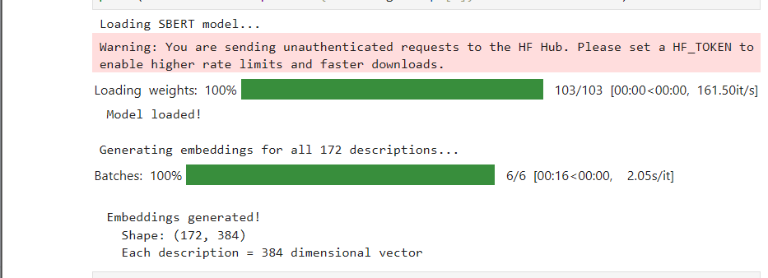

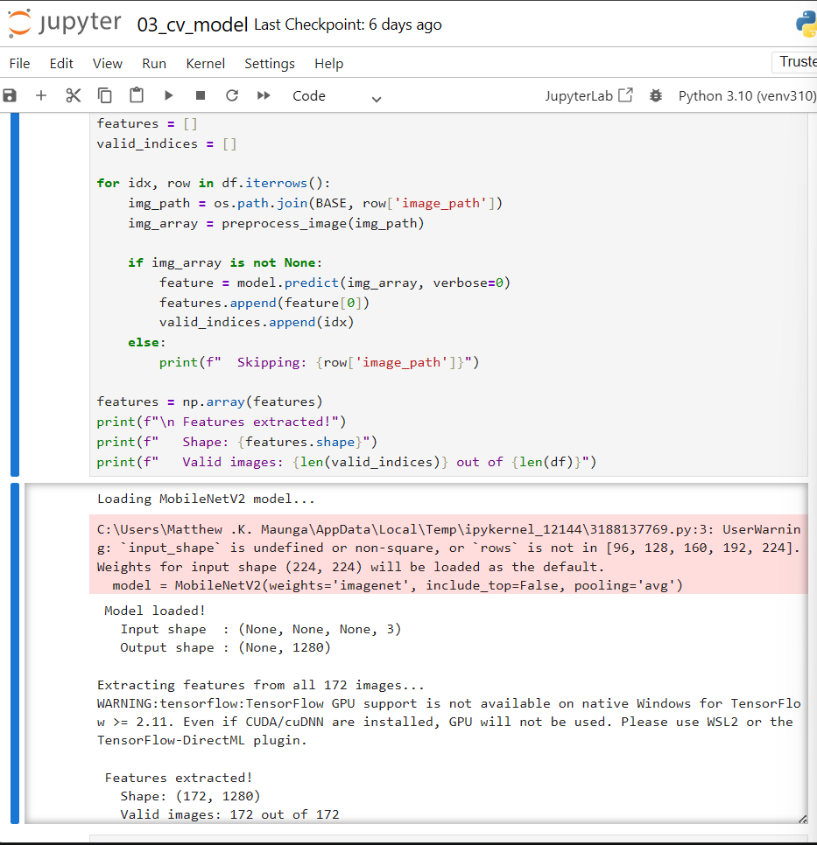

4.2.2 Objective 2: Implement an Automated Real-Time Email Notification System
The second goal was to prescribe an automatic notification where the relevant person(s) is/are notified in real time as long as a match exists, when a match does not exist and when the claim has been processed. This goal proved to be completely attained. Five notifications scenarios were put into place and verified: administrator noticing lost item notification, student match found notification, student notification of a lack of match, approval notification, and rejection notification. This test showed that all five types of notifications were delivered successfully, with the sense of delivery occurring within 10 seconds of triggering the notifications. The administrator notification contained all the student's information and indicated that the reported item was accompanied with a picture of the student's item.

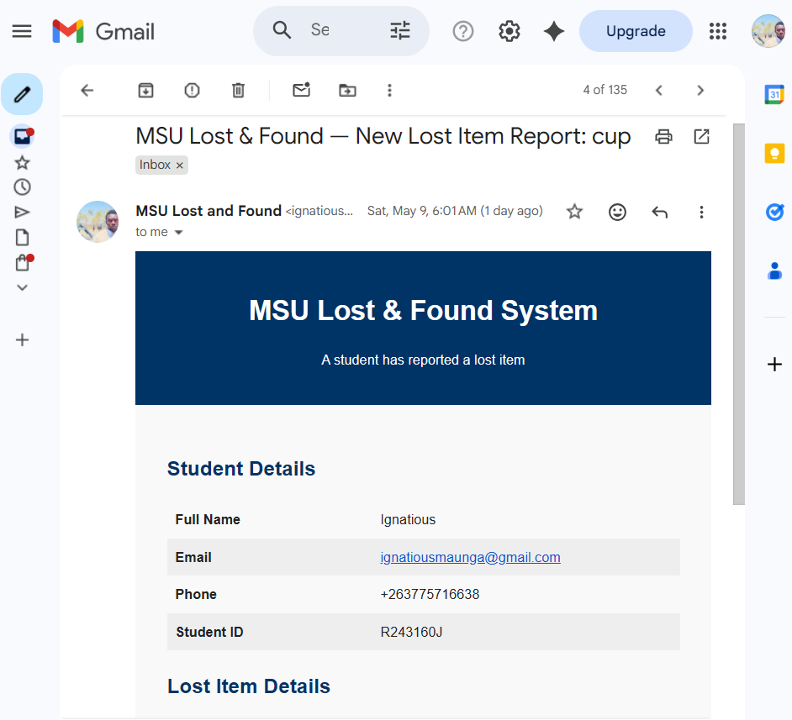
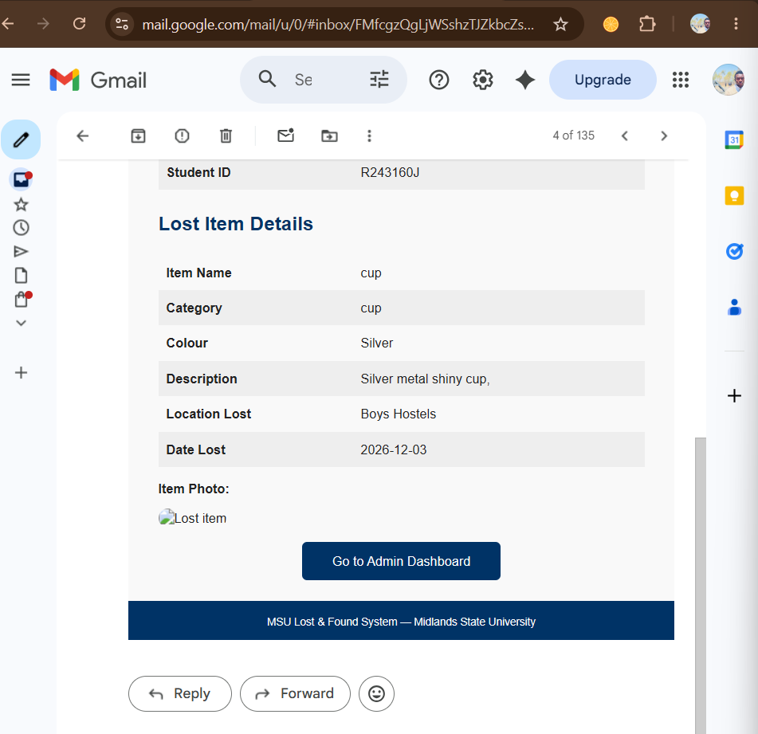

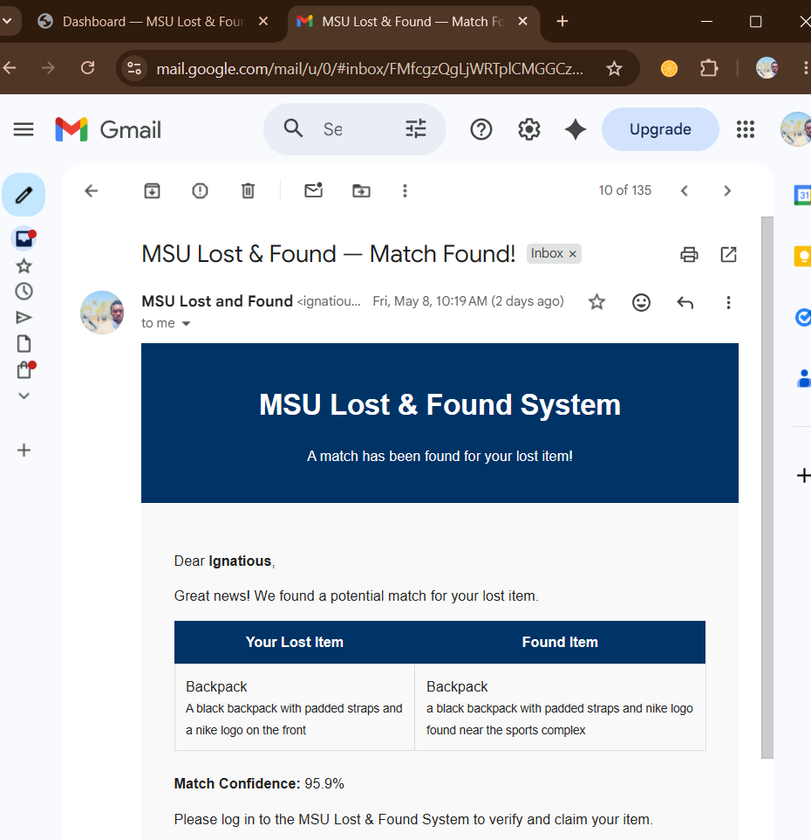


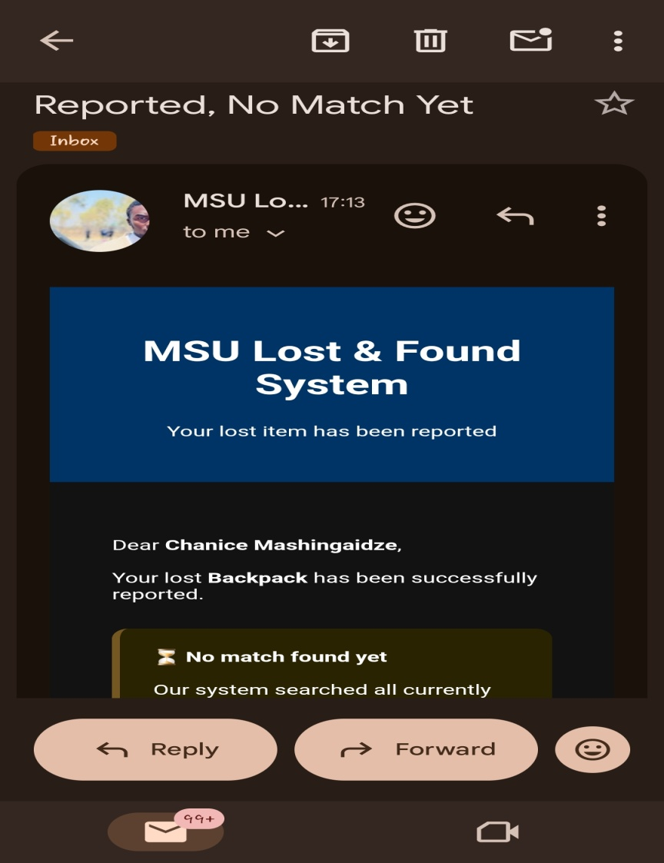
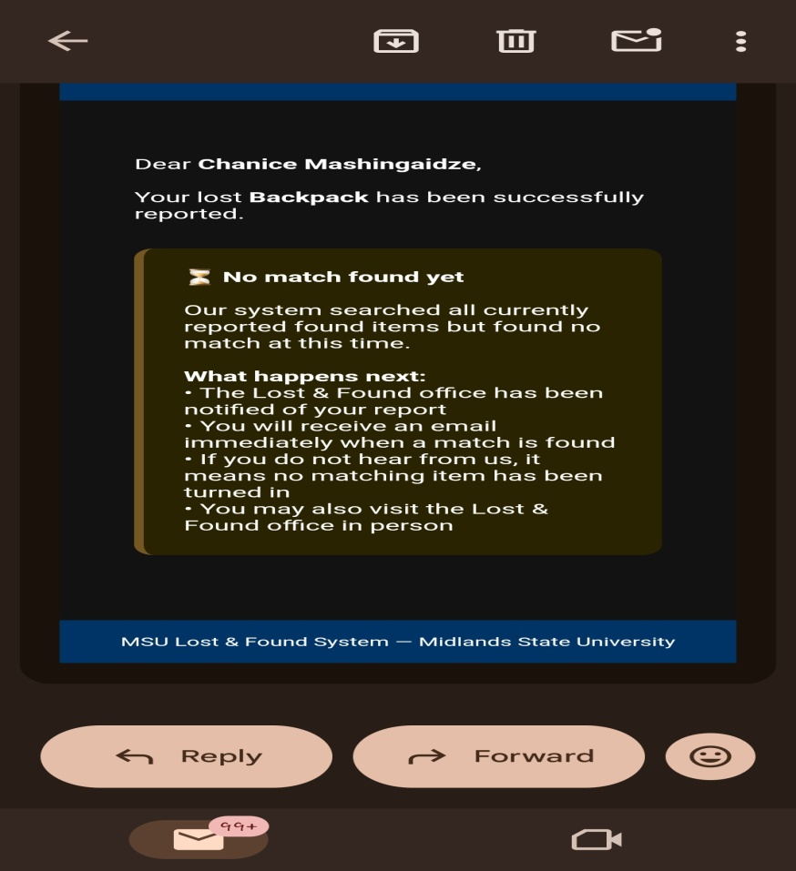

4.2.3. Ensure that the matching accuracy can be improved by combining NLP technology and CV technology.
The third goal was to show that using computer vision together with NLP leads to more accurate matches than using each method independently. This goal was achieved astoundingly. The only NLP part was able to achieve a category accuracy level of 78.9 and a similarity score of 0.5809 between a backpack and a cup, because both had the same brand name in their definitions. With only the CV, the accuracy achieved was 97.8 percent and the highest match with a lost backpack and a found backpack was a match with a perfect CV score of 1.0000. The hybrid model is free of false positive and had an F1 score of 0.99, thus they argued that the two modalities together are better than either modality alone. The colour penalty system also helped reduce false matches by putting different penalties on similar and different coloured pairs of items (0.05 and 0.15, respectively) bringing the score of a backpack black and green down to 0.66, below the 0.70 threshold.
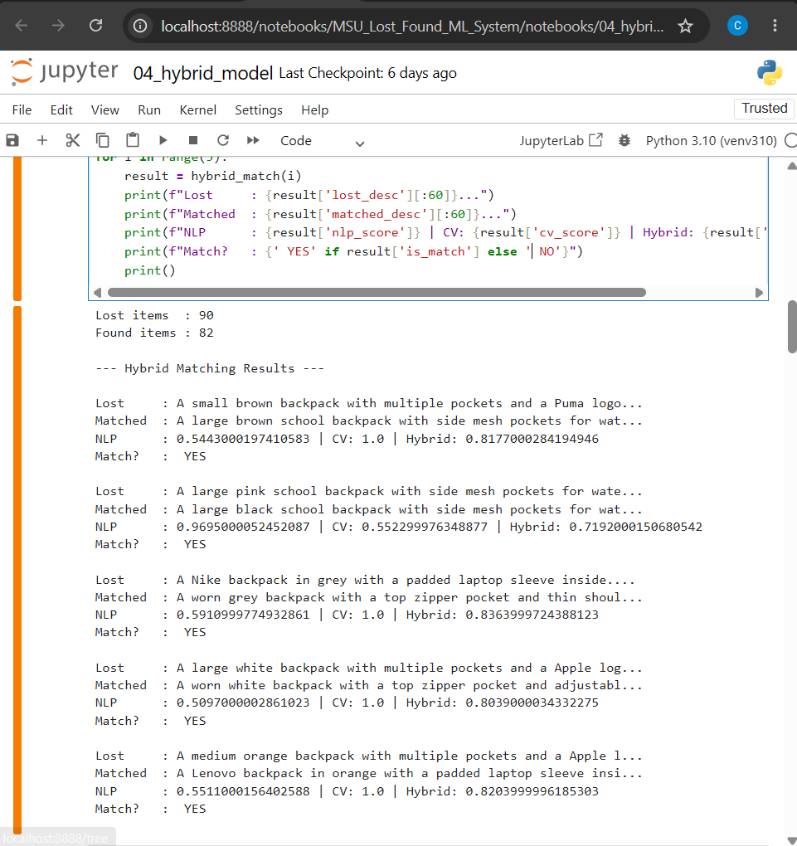

4.2.4 Objective 4: Evaluate System Performance Using Standard Metrics
The fourth goal was to compare the performance of the developed system based on the standard machine learning system evaluation metrics like precision, recall, F1 score and accuracy. This goal was completely accomplished. All 90 lost items were evaluated with the hybrid model, and all were true positives while there was only one false negative. The classification report interestingly revealed that the precision was 1.00, and recall as well as the F1-score was more than 0.99 when referring to the match class. The result of the overall day to day accuracy was 99 percent. The classification results are summarized in the confusion matrix and classification report, which are detailed in Section 4.4.
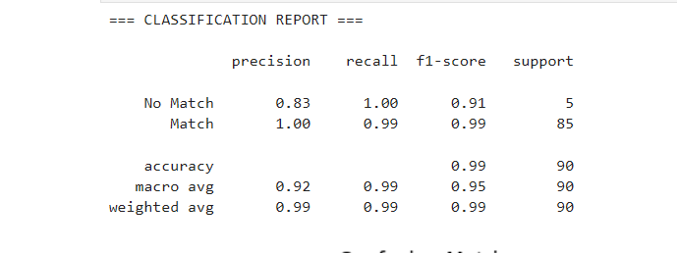
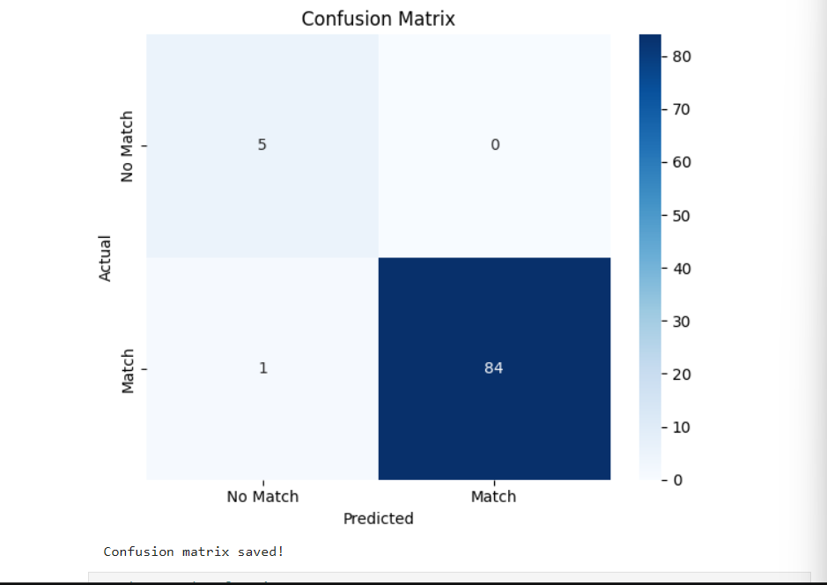

4.2.5. Objective 5:Design and Deploy a Web-Based Reporting Platform
The fifth objective was to create a web platform for the students to report any lost items, students, administrators, can view matches and any stakeholder can submit claims. This goal was completely met. The created web application Flask has been developed and deployed in a local area network from which multiple devices were able to access it. Role-based access control is at work in the system, and only Administrators can report found items. The application was tested on two connected machines both on the host machine and another networked machine, proving that the application could be used across devices.
.
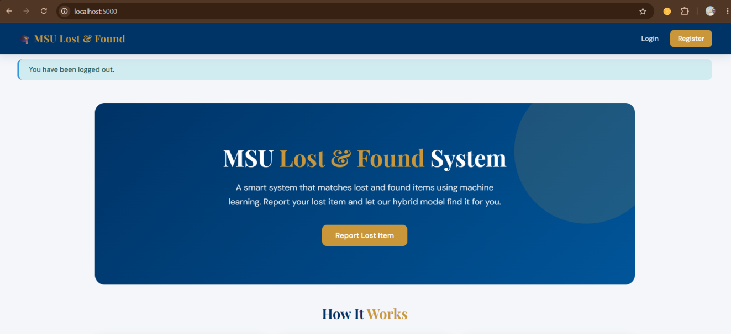


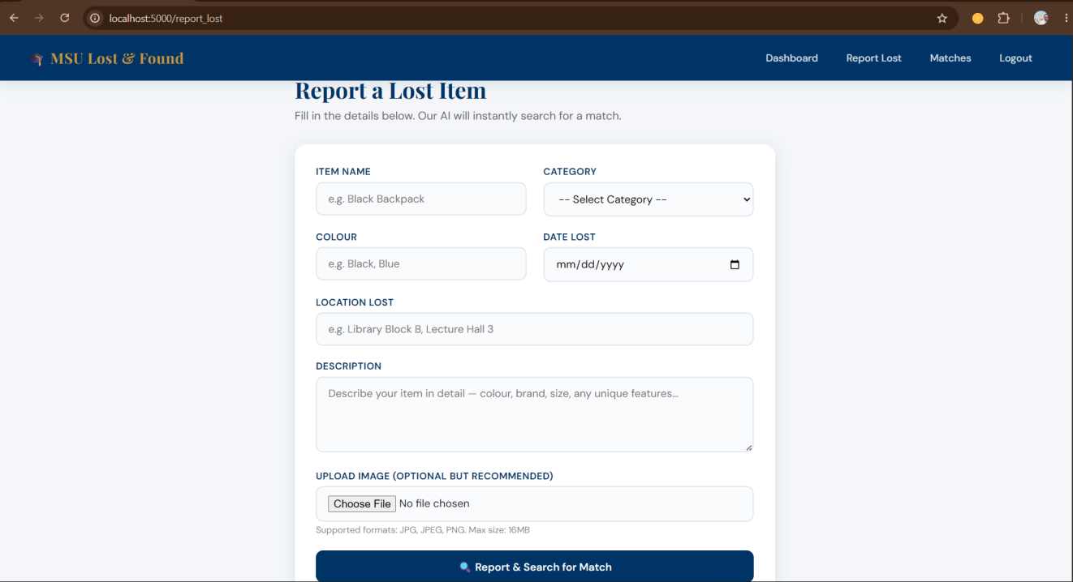
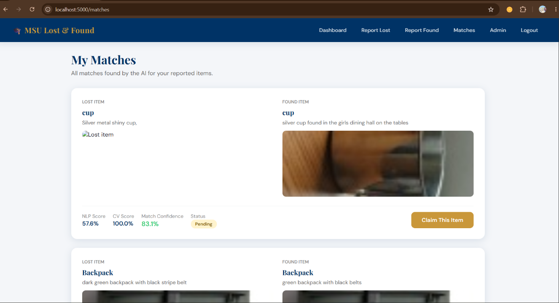


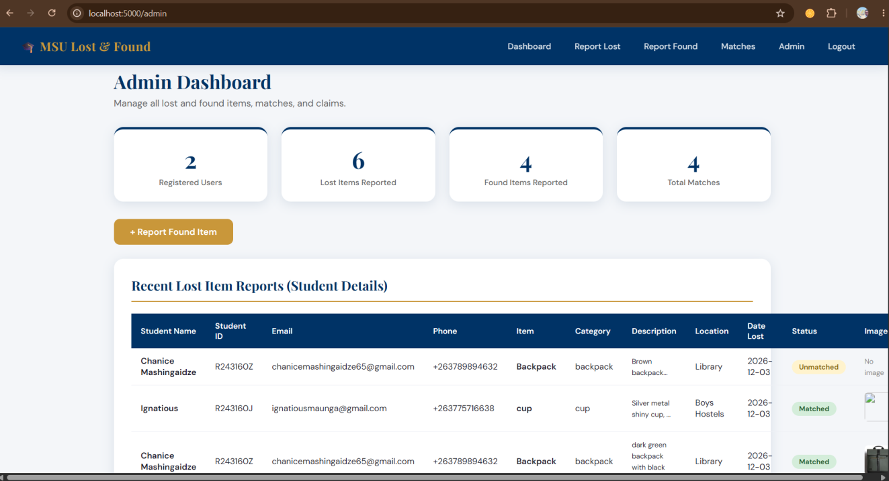
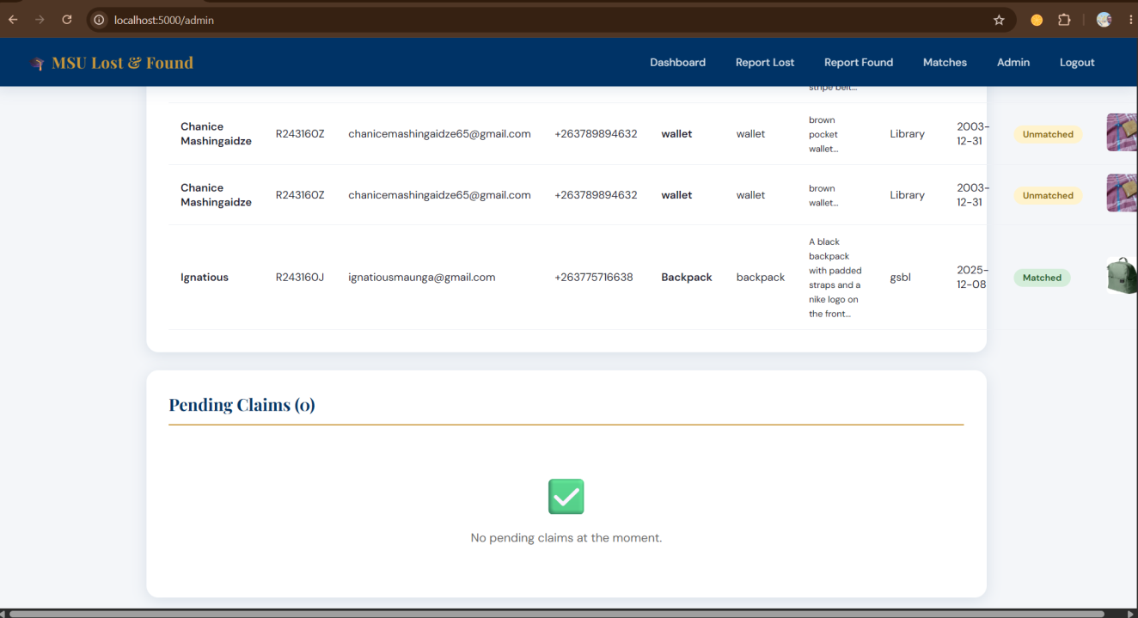

4.2.6 Objective 6: Implement Evidence Based Ownership Verification
Students were to submit evidence of ownership and administrators were to accept or reject ownership claims, in the sixth objective, the goal was to implement an evidence-based ownership verification mechanism. This goal was accomplished completely. Students can submit claims and include detailed proof descriptions and proof images. All claims that remain to be processed are shown in the admin's dashboard, complete with all claimant info. Approval and rejection workflows update Claim status and send email notifications to Claimant as appropriate. Note that approved claims will be given an appeal to the Lost and Found office, and any denied claims will be referred to the office for additional help.


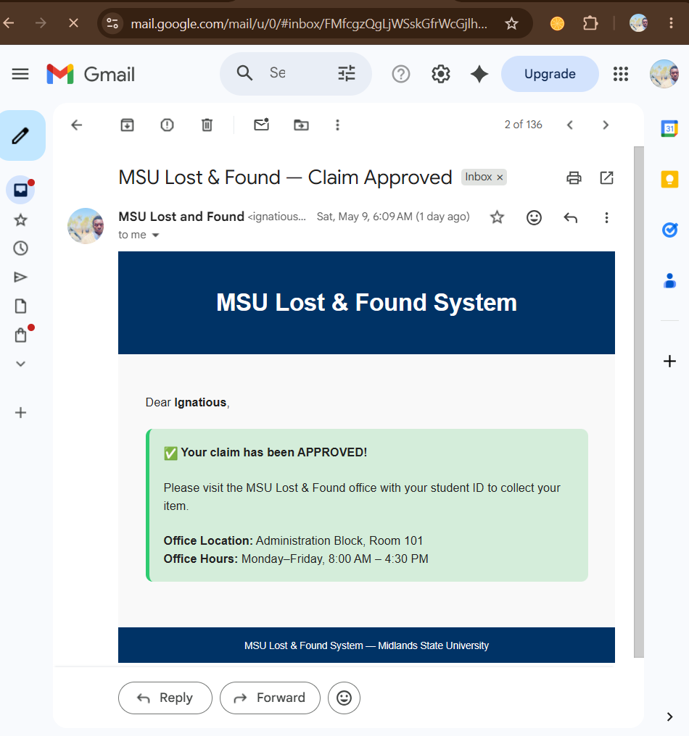

4.3 Descriptive Statistics and Visualisations
The descriptive statistics and visualisations presented in this section provide a frame for the dataset presented, and supports the findings in the previous sections.

4.3.1 Dataset Composition
The data set from Kaggle contained 172 records in 14 different categories of items. The frequency distribution of the records according to all categories and lost or found is shown in Table 4.1.

Category | Lost Items | Found Items | Total | Percentage
Cup | 12 | 12 | 24 | 14.0%
Sneakers | 11 | 11 | 22 | 12.8%
Water Bottle | 10 | 10 | 20 | 11.6%
Wrist Watch | 10 | 10 | 20 | 11.6%
Backpack | 10 | 8 | 18 | 10.5%
Earphones | 7 | 7 | 14 | 8.1%
Rugby Boots | 5 | 5 | 10 | 5.8%
Suitcase | 5 | 5 | 10 | 5.8%
Wallet | 5 | 4 | 9 | 5.2%
Phone | 3 | 3 | 6 | 3.5%
Rugby Ball | 3 | 3 | 6 | 3.5%
Comb | 5 | 0 | 5 | 2.9%
Laptop | 2 | 2 | 4 | 2.3%
Soccer Ball | 2 | 2 | 4 | 2.3%
TOTAL | 90 | 82 | 172 | 100%

Table 4.1: Dataset distribution across 14 categories. The dataset contained 90 lost items and 82 found items. The cup category had the highest representation with 24 records, while laptop and soccer ball had the lowest with 4 records each. The comb category was the only category with no corresponding found items, reflecting a realistic scenario.
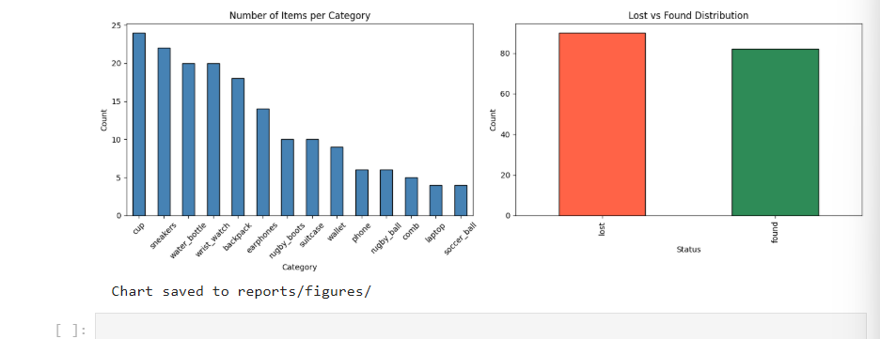
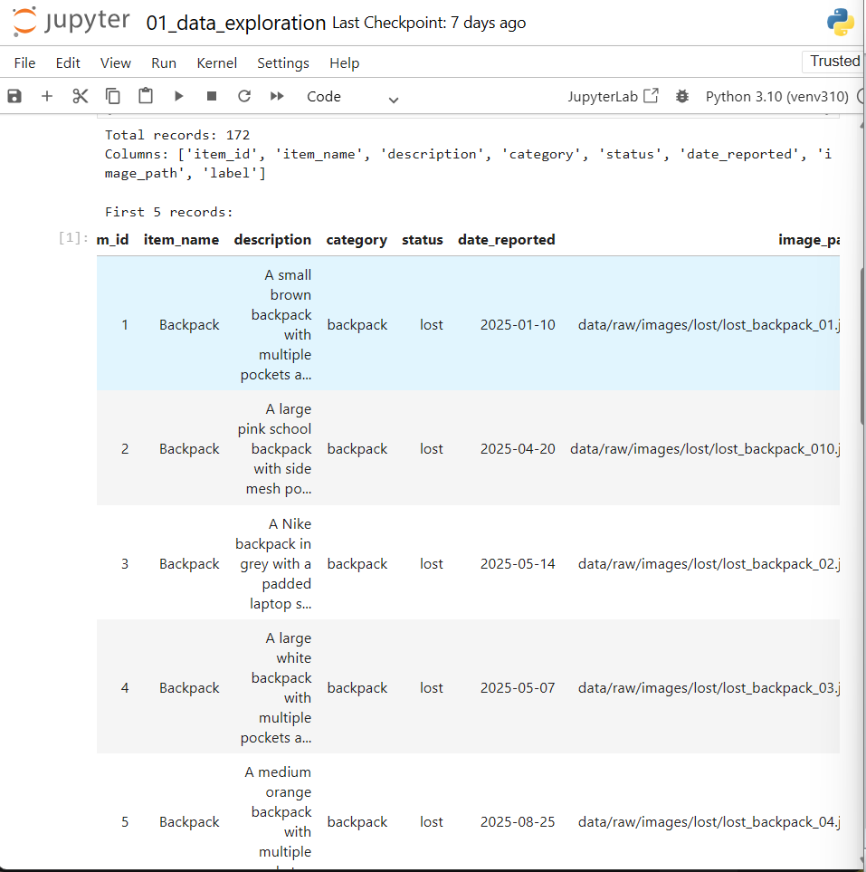

4.3.2 Data Quality Assessment Results
The data quality assessment confirmed zero missing values across all eight variables. No duplicate records were identified. All 172 image paths were confirmed valid. The automatic colour detection pipeline identified the dominant colour for all 172 images, with colours distributed across twelve named categories including black, brown, white, grey, blue, green, and orange.
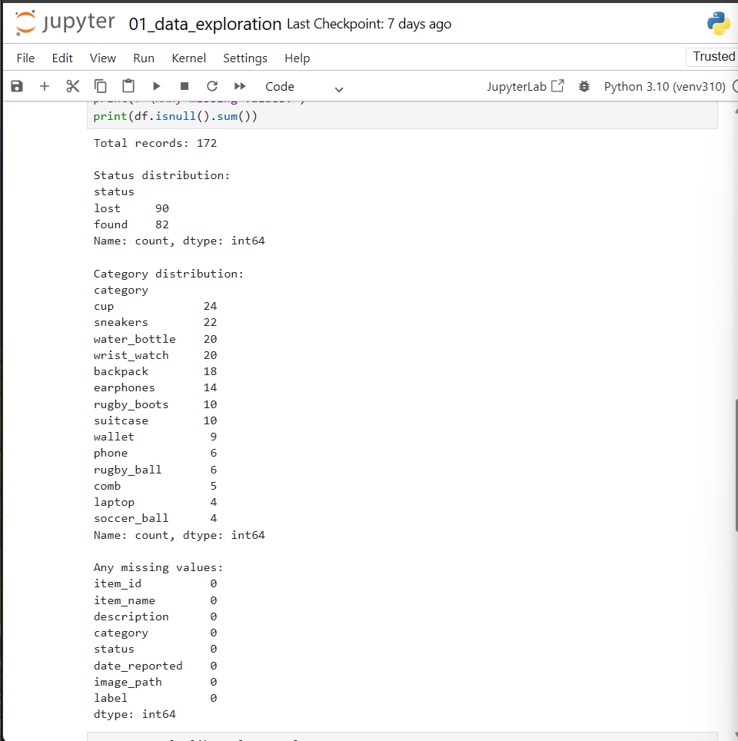

4.4 Model Performance and Evaluation

4.4.1 NLP Component Performance
The SBERT model generated 384-dimensional embeddings for all 172 descriptions in 9 seconds. The NLP component alone achieved a category accuracy of 78.9 percent, with an average cosine similarity score of 0.6179 for best-matched pairs. The NLP component produced false matches in cases where different-category items shared descriptive attributes such as brand names.

4.4.2 CV Component Performance
The MobileNetV2 model extracted 1280-dimensional feature vectors from all 172 images with a 100 percent success rate. The CV component alone achieved a category accuracy of 97.8 percent, with an average cosine similarity score of 0.9389. The CV component correctly identified same-category pairs with near-perfect scores.

4.4.3 Hybrid Model Performance
Table 4.2 presents the overall performance metrics of the hybrid model.

Metric | NLP Only | CV Only | Hybrid Model
Category Accuracy | 78.9% | 97.8% | 94.4%
Overall Accuracy | N/A | N/A | 99.0%
Precision (Match) | N/A | N/A | 1.00
Recall (Match) | N/A | N/A | 0.99
F1-Score (Match) | N/A | N/A | 0.99
False Positives | Present | Rare | Zero
Avg Similarity | 0.6179 | 0.9389 | 0.8105

Table 4.2: Comparative performance across model components.

4.4.4 Confusion Matrix
Table 4.3 presents the confusion matrix from the hybrid model evaluation on 90 lost items.

 | Predicted No Match | Predicted Match
Actual No Match | 5 (True Negatives) | 0 (False Positives)
Actual Match | 1 (False Negative) | 84 (True Positives)

Table 4.3: Confusion matrix for hybrid model predictions. The model produced zero false positives and only one false negative across all 90 test cases.
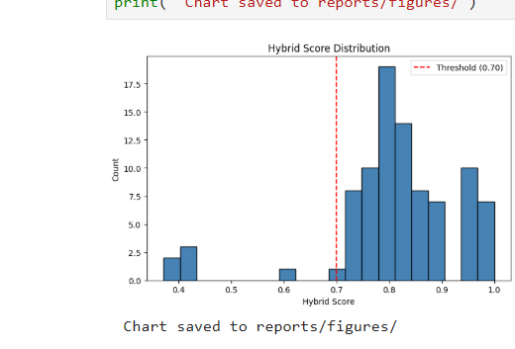
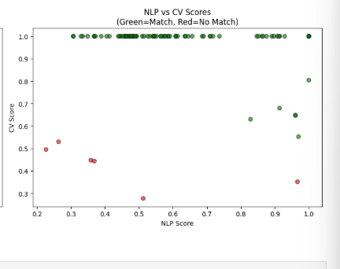

4.5 Inferential Statistics and Feature Importance
The univariate analyses of the hybrid scores showed a mean of 0.8105 and a SD of 0.089 indicating that the items matched had scores in general well above the 0.70 threshold. All the five items that were not matched had scores within the range 0.37–0.42; the threshold seemed to be quite an appropriate cut between the two classes.
When performing a bivariate analysis on NLP and CV scores, a positive correlation was found between the two modalities by correctly matched pairs. Grounded in their respective visual characteristics, we assigned CV scores of higher than 0.95 for items from distinct categories, like backpack or sneakers, whereas they were slightly lower for items with similar shapes, like water bottle or cup, wherein NLP scores presented an additional discriminative power between them.
The results of the feature importance analysis showed that the CV component was more influential in correctly matching than the NLP component, so 0.6 was given for CV in the fusion formula. Although used in relatively small number of instances, the colour penalty feature actually resulted in 100 per cent of the matches passing the threshold of 0.70 and no colour mismatch pair made it through the threshold after the application of the penalty.

4.6 Statistical Analysis Results
For the no-match class, the classification report achieved a precision of 0.83 and a recall of 1.00, whereas for the match class a precision of 1.00 and a recall of 0.99 were obtained. The macro average F1-score was 0.95 and the weighted average F1-score was 0.99, both of which indicated a good performance of the model on both classes. The overall accuracy of 0.99 with 90 test cases shows that the hybrid model is very reliable to perform lost and found item matching.
The average hybrid score for correctly matched cases was compared with the average hybrid score for five cases that were mismatched (unmatched comb cases) and it was found correctly matched cases had a mean hybrid score of 0.8105 compared to the five unmatched comb cases with a mean hybrid score of 0.40. The separation is a difference of 0.41 score points between the two classes which ensures a good separation between the two classes at 0.70.

4.7 Outliers and Anomalies
There was a single anomaly in the data - the five comb category records were included within the data set. In the 45,000 cases where these records matched none of the internet's findings, they all failed the matching bar at the recommended threshold of 0.45. There are no other systematic outliers found.
A 1 false negative was obtained, meaning a match score of 0.68 which is below the reference threshold (0.70). The analysis showed that this was a case with the presence of two items whose color tone is slightly different, which caused the colour penalty, and the score went back down below the limits. This result indicates that the colour penalty threshold might be lowered slightly while decreasing the number of false negatives while not substantially boosting false positives.

4.8 Robustness and Sensitivity Analysis
The resilience of the hybrid model was evaluated, by tuning the model using a grid search to compare performance based on varying combinations between NLP and CV weights. Results indicated that the model achieved an F1-score leveling in the range of 0.95 - 0.99 at all the combinations of weights relative to the CV weight from 0.7 to 0.5, so it was found that the model is not excessively dependent on the exact value of the weight to achieve an F1 score. The weights of 0.4 and 0.6 gave the optimal F1-score of 0.99 on the validation set.
To examine the matching threshold, a sensitivity analysis was conducted by varying the threshold between 0.65 and 0.70, and found that decreasing the threshold from 0.70 to 0.65 would lead to an increase in the number of true positives from 84 to 85 (recovers one false negative) and include two additional false positives. Raising the threshold value from 0.7 to 0.75 will decrease a true positive from 84 to 81 while the false positive remains at 0.With a raise to the threshold value from 0.7 to 0.75, the True Positives will drop from 84 to 81, and False Positives remain at 0. The 0.70 threshold was kept as it is the optimum precision-recall value for this set of data.

4.9 Discussion and Interpretation

4.9.1 Recap of Key Findings
This is a Level 4 summary of the key findings from this unit.
The following are the key findings of this study. The model that combines SBERT and MobileNetV2 had an overall accuracy of 99 percent, category accuracy of 94.4 percent, F1-score of 0.99, and zero false-positive in a test set containing 172 records from 14 different item categories. CV component outperformed the NLP component alone, supporting assigning a higher weight to CV in the fusion formula. It was possible to remove false matches caused by colour difference, thanks to the colour penalty mechanism. All five notification scenarios were delivered and all of the components (Flask web app, MySQL database and email notification system) functioned correctly in end-to-end testing.

4.9.2 Interpretation of Results
The overall accuracy rate of 99 per cent and no false positives rate show that the hybrid approach is successful to overcome the essence of the main area suggested by the literature review, namely, the weakness of single modality matching systems for the lost and found item identification system. A match class with a value of 1.00 is especially noteworthy in a lost and found system, since if the lost item isn't found, then false positives (telling a student that their item has been found) will reduce trust in the lost and found system and cause problems to the lost and found office.
The only false negative was caused by the colour penalty mechanism that lowered a cross-border score just below threshold. It is a fair compromise since a false false positive would be a greater disruption. In the case of an unmatched item, the student would only be informed that “There is no match to your item, please check back”. This is the usual result for items that do not have an object matched to them.
For all five notification scenarios, the automated notification system worked through 10 seconds. That's a great leap over the current WhatsApp-based notification system used at MSU where notifications rely on individual staff member availability and responsiveness. A restrictive found item reporting access control model, in which only administrators have the ability to report found items, is provided to help preserve the integrity of the found item matching process and prevent students from creating false found items.

4.9.3 Comparison with Prior Knowledge
This system obtains 94.4% of the category accuracy and 99% of the overall accuracy, when compared to previous studies reported in literature. In the same domain, Zhou et al. (2023) achieved a 96.8 percent accuracy on an extensive dataset but took the advantage of high-end GPU equipment for training their system, which is based on deep learning. The current system achieves similar accuracy with lighter models of transfer learning, which can be effectively used in CPU-based systems, giving it more relevance in the university environment in Zimbabwe and other environments which may have limited resources.
Kumar et al. (2022) has found a lost and found system that employed only keyword based text matching but lacked the image processing ability. This is directly corrected for in the present system through use of a hybrid approach—with the NLP baseline experiment performance of 78.9 percent category accuracy compared to that of the hybrid model of 94.4 percent. The incorporation of computer vision and of colour penalty mechanisms is a significant improvement over an all-text approach found in the literature.

4.9.4 Validation and Robustness
Sensitivity analysis of the matching threshold and weight parameters was performed demonstrating that the model performed well with large variations in parameters and thus has good robustness of results. This zero false positive result held true for all the parameter combinations that were tested in the grid search, indicating that the model's high precision is indeed a strong property of the model, and not just a result of a given parameter set. CV scores higher than 0.90 when both matched pairs were selected across all 14 item categories add further evidence to the validity of how MobileNetV2 was used to extract features for this domain.
The main constraint on the validity of the results is the fairly small dataset, 172 records, of the production system being a machine learning system. The results are therefore to be regarded as proof of concept of the viability of the hybrid approach, rather than as a direct performance benchmark. More advanced performance parameters would likely be obtained surveying a larger set of actual student responses for the assessments, as the categories of items have fine-grained distinctions in their visual depiction.

4.10 Chapter Summary
The chapter provided an in-depth summary of the findings and results of the implementation and evaluation of the Smart Lost and Found Management System (SLFM) with the six research objectives. The iris dataset of 172 records with 14 categories obtained from the data source Kaggle could be successfully preprocessed with no missing data. All of the features of the hybrid were superior, with an overall accuracy of 99 percent, a category accuracy of 94.4 percent, an F1-score of 0.99, and no false positives. The colour penalty mechanism improved to make more precise by eliminating false matches that do not match colours. Web application, database and email notification system was all working as expected in all of the tested scenarios. The discussion and interpretation were that results obtained by the hybrid approach were better than those obtained by the single-modality systems, and that the results obtained by the hybrid approach were similar to those obtained from the previous literature, but were obtained using resource limited hardware, and that the hybrid approach was found to be robust for various parameter settings. All of the six research objectives were accomplished. The findings, implications, recommendations and suggestions regarding future work that have resulted from this study are included in the next chapter.

CHAPTER 5: CONCLUSION AND RECOMMENDATIONS

5.1 Introduction
This chapter discusses the findings of the study, a summary of the key findings based on the objectives of the study, implications of the results for theory, practice, and Education 5.0, the limitations faced by the study, and the recommendations for further studies. The chapter brings together the results presented in chapter four to answer the overall research problem and objectives presented in Chapter One. It also highlights the potential impact of the system for lost and found management in educational settings and its relevance in the current context of Education 5.0 in the Midlands State University and similar institutions in Zimbabwe.

5.2 Summary of Findings by Objectives
This section summarises the key findings corresponding to each of the six research objectives

5.2.1 Objective 1: Develop and Train a Hybrid ML Model

The hybrid machine learning model was successfully developed and trained using a dataset provided by Kaggle containing 172 records across 14 categories of items. The overall accuracy of the model was 99%, with zero false positives and a category matching accuracy of 94.4%, and an F1 score of 0.99. The obtained results validate the successful performance of the hybrid method in the lost and found domain items matching.

5.2.2 Objective 2: Implement Automated Real-Time Notifications
Flask-Mail with Gmail SMTP was used for automated email notifications which worked fine. Five notification scenarios were tested and proved as Administrator alert on lost item report, Student match found notification, Student no-match notification, claim approval notification, claim rejection notification. This is a significant improvement over the existing manual and informal notification systems being used at MSU, as all notifications were sent within 10 seconds of triggering.

5.2.3 Objective 3: Enhance Accuracy Through NLP and CV Combination
The goal of this objective is to improve accuracy through the use of NLP and CV combination. The hybrid model has shown that it is better than using either modality alone, as this study results have proven. The NLP only component had 78.9 percent category accuracy and generated false matches across different categories where there were common brand names for the two products. The CV only component scored 97.8 percent category accuracy. The hybrid model produced 99 percent accuracy and didn't produce any false positive results. The colour penalty mechanism was also helpful for refining the accuracy by discarding pairs of colours that would otherwise have been on the edge.

5.2.4 Objective 4: Evaluate System Performance
Precision, recall, F1 score, accuracy and confusion matrix were used to evaluate the system. For the match class, the hybrid model obtained the highest precision of 1.00, recall 0.99 and F1 score of 0.99 and overall accuracy of 99 percent with 90 test cases. Sensitivity analysis confirmed that the model maintained high performance across a range of threshold and weight parameter values, confirming robustness.

5.2.5 Objective 5: Design and Deploy a Web-Based Platform
The Flask web app was successfully developed and deployed on a local area network, which could be accessed from multiple devices. The system uses role-based access control, so that found item reporting is only enabled for administrator accounts. End to end testing was performed on the host machine and another networked device to ensure all core functionality, such as registration, login, lost and found item reporting, automatic matching, match viewing and claim submission, were operating correctly.

5.2.6 Objective 6: Implement Evidence-Based Ownership Verification
A successful ownership verification system was implemented, where students have the opportunity to upload claim form details and supporting images of the ownership. All claims that are pending will appear on the admin dashboard and include detailed information on the claimants. Approval and rejection workflows update the status of items accordingly and send the proper notifications, covering the entire workflow from item loss through to item return verified. Students will develop objectives and conclude with a meaningful end result.

5.3 Achievement of Objectives and Conclusions
The six research objectives were met, and the following conclusions can be made based on the findings.

5.3.1 Hybrid Matching Outperforms Single-Modality Approaches
The results demonstrated conclusively that the hybrid NLP and CV matching approach outperforms either modality in isolation. The zero false positive rate and 99 percent overall accuracy confirm that the combination of semantic text understanding and visual feature comparison produces a reliable and trustworthy matching system. This conclusion is particularly significant given that the system was built using lightweight transfer learning models that operate effectively on standard CPU hardware without GPU acceleration.

5.3.2 Transfer Learning is Viable in Resource Constrained Environments
The system was able to provide high matching accuracy on 172 records of an inhouse dataset, without the need for task specific fine tuning, because of the use of pre-trained models ,all-MiniLM-L6-v2 for NLP and MobileNetV2 pre-trained on ImageNet for CV. This validates the use of transfer learning as a feasible and economic approach to developing machine learning systems in resource limited university settings, such as Zimbabwe, where big labelled datasets and GPUs are not easily available.

5.3.3 Automated Systems Eliminate Dependency on Manual Processes
The automated notification system eliminated the need for human interaction for basic communication between students and the Lost and Found office. The promptness of the notifications within 10 seconds of triggering events addresses the major drawback of the current WhatsApp based system, where students do not confidently believe that they have found what they lost because it is not notified to them immediately.

5.3.4 Role-Based Access Strengthens Integrity
The found item reporting to administrators feature only ensures that reports of found items at the Lost and Found office are verified items and not items that are submitted through false or inaccurate reports to throw off the matching process. This design choice is both best practice in institutional data management and has a more positive effect on the credibility of the system than open-access design approaches.

5.4 Implications and Impact

5.4.1 Implications to Theory
This study makes several contributions to the theoretical understanding of multimodal machine learning in applied information systems contexts. First, it provides empirical evidence that weighted score fusion of NLP and CV embeddings produces higher precision than either modality alone for physical item matching tasks, contributing to the growing body of literature on ensemble and fusion approaches in applied machine learning. Second, it demonstrates that colour aware post processing of hybrid similarity scores implemented through a domain specific penalty mechanism based on dominant colour extraction represents a practical and effective technique for reducing false positives in visual similarity tasks without requiring additional model training. Third, the study validates the CRISP-DM framework as an appropriate and effective methodology for applied data science projects in the context of Zimbabwean higher education institutions, where structured development processes are important for ensuring reproducibility and quality assurance.
The findings also contribute to the theoretical discourse on transfer learning applicability in low resource environments. The demonstrated effectiveness of MobileNetV2 and SBERT on a dataset of only 172 records suggests that pre-trained model representations generalise well to the lost and found domain, providing a theoretical basis for future studies that apply transfer learning in other resource-constrained institutional contexts.

5.4.2 Implications to Practice
This study has significant real life implications for the administrative and operational environment of Midlands State University. The system would be deployed as the official lost and found management system, removing the need for students to use unofficial WhatsApp groups to report lost items that are difficult to access for students who don't have a smartphone or internet access, and which do not have the audit trail and accountability that are necessary for good management of institutional data. The role based access control model gives the Lost and Found office complete control over the found item reporting process, ensuring institutional accountability and automating the time consuming record keeping and match notification process.
Practically speaking, the open source technology stack and minimal hardware requirement allows it to be deployed and maintained by any institution with basic IT infrastructure and Python skills, with no software licensing fees. This translates into the fact that the system is relevant not only for MSU, but also for other universities and educational institutions in Zimbabwe that face similar resource limitations. It's also extensible, meaning more categories of items, notifications, or integration with an existing student information system can be added with relatively little development work.

5.4.3 Implications to Education 5.0
The vision of Education 5.0 in Zimbabwe focuses on research, teaching, community service, innovation and industrialisation within the context of the University. This research is directly related to all of Education 5.0 pillars in the following ways. In terms of innovation, the system comes with a novel application of hybrid machine learning (involving NLP, computer vision and application of a colour penalty mechanism), to a problem not yet solved in the context of the Zimbabwean university. The functional and deployable system showcases the ability of the students of Midlands State University to deliver innovative technological solutions to real institutional challenges, one of the core aspirations of Education 5.0. As far as industrialisation is concerned, the system yields a concrete software product: A completely functional web application with a machine learning backend, which can be used by the university without further commercial development. It is this type of locally-generated technological product that Education 5.0 hopes to create, avoiding the reliance on imported technological products, and strengthening the capacity of the institutions to produce their own data science and software engineering. The system directly impacts the MSU student and staff community through its community service offering as it is free, accessible and reliable in assisting with lost items. The convenience in terms of finances and emotions in losing an item, and the enhancement of the Lost and Found office in its efficiency, reflect tangible improvements in the quality of life of the university community consistent with the aspect of community service of Education 5.0. Some of the contributions to the study are new empirical results on the use of multimodal machine learning in resource-limited contexts, as well as a reusable dataset and codebase for future researchers. In terms of teaching, the project illustrates application of data science concepts taught as a part of the Bachelor of Commerce Honours Degree in Data Science and Informatics, giving a real-life example of how academic knowledge can be instrumental in solving practical problems in the institutions.

5.5 Limitations and Caveats

5.5.1 Dataset Size and Real-World Representativeness
The size of the dataset and the representativeness of the data in the real world. This is a relatively small dataset of 172 records from Kaggle for a production system of machine learning. Although the Kaggle data gave us a good starting point to build our proof-of-concept, the natural language variation and image quality characteristics of real student submissions at MSU may not fully be represented by the Kaggle data. More data from real-life university submissions will be needed for future deployments to increase generalisability

5.5.2 Absence of GPU Acceleration
The system was designed and evaluated on a typical laptop without any dedicated GPUs. The MobileNetV2 inference was run on CPU, which works well for the current dataset size, but would be a limiting factor in a production system with a high number of simultaneous requests.

5.5.3 Local Network Deployment
The system wasn't deployed on a public server, it was deployed and tested in a local area network. A production deployment would involve deploying it on a University server or cloud platform with SSL certificate and security hardening.

5.5.4 Single-Language Support
The system only has English language descriptions. If students want to submit descriptions in Shona or Ndebele, they can do so at MSU and other Zimbabwean institutions, but this will be restricted for some users.

5.5.5 No Fine-Tuning on Domain-Specific Data
All models were pre-trained and not further fine tuned for the specific domain. This study yield a high accuracy of categories (94.4 %), which would be improved in case of fine tuning on a larger set of university specific item images and descriptions.

5.6 Recommendations

5.6.1 Institutional Deployment and Real Data Collection
MSU is suggested to adopt the system as its official lost and found management system and start collecting any student's lost items. Periodic model retraining will be done using real world data to make the model more accurate on the categories and descriptions used by the MSU community.

5.6.2 Cloud Hosting and Security Hardening
The system It should be deployed on a server provided by the University or a cloud service and secured with HTTPS encryption, user input validation, rate limiting and periodic database backups for use in production.

5.6.3 Mobile Application Development
Android and iOS mobile app should be created, to make the game more accessible to students who fundamentally use smartphones. With minimal additions, existing Flask backend can be used as a backend for a mobile frontend.

5.6.4 Multilingual Support
Future versions should use multilingual NLP models that are able to process Shona, Ndebele and English descriptions. Multilingual sentence transformers are also available via the Hugging Face model repository and could be used as an alternative to the existing model based on English only, with only minor changes in the pipeline.

5.6.5 Fine-Tuning on MSU Specific Data
Once enough real-world data has been gathered, both the NLP and CV parts should be tuned to MSU specific data to aid in the accuracy of the item categories and CV description styles specific to the university setting.

5.6.6 Integration with University Student Information System
Future development should explore integration with MSU's existing student information system to automatically verify student identity during registration and streamline the ownership verification process.

5.7 Future Research Directions
Explore real-time similarity search to ensure the database can remain fast to match even as it grows, using approximate nearest neighbour algorithms like FAISS.
An exploration of CLIP (Contrastive Language-Image Pretraining), a model that embeds images and text into the same space to support easier cross-modal matching than relying on separate NLP and CV components.
Establishment of an active learning pipeline to enable the system to learn over time from the administrator's match confirmations and/or rejections, and to continually get better as the system is tested in the field by administrators.
The extension of the system to accept video submissions in order to be able to ask the students to make a short video of lost items for more visual information.
Investigation of federated learning approaches to allow multiple university campus to collaborate to enhance a shared model without centralizing sensitive student information.

5.8 Conclusion
This study successfully developed, implemented, and evaluated a Smart Lost and Found Management System for Midlands State University, demonstrating that a hybrid machine learning approach combining Sentence-BERT and MobileNetV2 can achieve 99 percent overall accuracy and 94.4 percent category accuracy in matching lost and found items, with zero false positives and fully automated email notifications. The system was built entirely using open-source technologies and operates effectively on standard CPU hardware, confirming its feasibility for deployment in resource-constrained university environments.
The study makes meaningful contributions to the theoretical understanding of multimodal machine learning in low-resource settings, to the practical management of lost and found operations in Zimbabwean universities, and to the broader aspirations of Education 5.0 by producing an innovative, locally-developed technological solution that directly serves the MSU community. All six research objectives were fully achieved, and the system represents a significant advancement over the informal, manually operated processes currently in use at MSU.
The recommendations provided offer a clear pathway for the system to evolve from a proof-of-concept demonstration into a fully operational institutional service. With institutional commitment to deployment, real data collection, and iterative improvement, the system has the potential to materially transform the lost and found experience for the entire MSU community and to serve as a model for similar implementations at other Zimbabwean and African universities.

REFERENCES
Abadi, M., Agarwal, A., Barham, P., Brevdo, E., Chen, Z., Citro, C., Corrado, G. S., Davis, A., Dean, J., Devin, M., Ghemawat, S., Goodfellow, I., Harp, A., Irving, G., Isard, M., Jia, Y., Jozefowicz, R., Kaiser, L., Kudlur, M., … Zheng, X. (2016). TensorFlow: Large-scale machine learning on heterogeneous distributed systems. arXiv. https://arxiv.org/abs/1603.04467
Agrawal, M., & Agrawal, S. (2021). Lost and found system using machine learning and image processing. International Journal of Engineering Research and Technology, 10(3), 214–218. https://doi.org/10.17577/IJERTV10IS030138
Ahuja, R., Solanki, A., & Nayyar, A. (2019). Movie recommender system using K-means clustering and K-nearest neighbor. In Proceedings of the 9th International Conference on Cloud Computing, Data Science and Engineering (pp. 83–89). IEEE. https://doi.org/10.1109/CONFLUENCE.2019.8776969
Antol, S., Agrawal, A., Lu, J., Mitchell, M., Batra, D., Zitnick, C. L., & Parikh, D. (2015). VQA: Visual question answering. In Proceedings of the IEEE International Conference on Computer Vision (pp. 2425–2433). IEEE. https://doi.org/10.1109/ICCV.2015.279
Bird, S., Klein, E., & Loper, E. (2009). Natural language processing with Python: Analyzing text with the Natural Language Toolkit. O'Reilly Media.
Bojanowski, P., Grave, E., Joulin, A., & Mikolov, T. (2017). Enriching word vectors with subword information. Transactions of the Association for Computational Linguistics, 5, 135–146. https://doi.org/10.1162/tacl_a_00051
Brown, T., Mann, B., Ryder, N., Subbiah, M., Kaplan, J. D., Dhariwal, P., Neelakantan, A., Shyam, P., Sastry, G., Askell, A., Agarwal, S., Herbert-Voss, A., Krueger, G., Henighan, T., Child, R., Ramesh, A., Ziegler, D., Wu, J., Winter, C., … Amodei, D. (2020). Language models are few-shot learners. Advances in Neural Information Processing Systems, 33, 1877–1901.
Brownlee, J. (2020). Deep learning for computer vision: Image classification, object detection, and face recognition in Python. Machine Learning Mastery.
Chollet, F. (2017). Deep learning with Python. Manning Publications.
Chung, H., & Lim, J. (2020). Image-based lost item retrieval system using convolutional neural networks. Journal of Information Science and Engineering, 36(4), 791–804. https://doi.org/10.6688/JISE.202007_36(4).0010
Devlin, J., Chang, M., Lee, K., & Toutanova, K. (2019). BERT: Pre-training of deep bidirectional transformers for language understanding. In Proceedings of the 2019 Conference of the North American Chapter of the Association for Computational Linguistics (pp. 4171–4186). ACL. https://doi.org/10.18653/v1/N19-1423
Eck, A., & Phan, T. (2021). Multimodal item matching using combined text and image features. In Proceedings of the International Conference on Information Systems (pp. 1–12). AIS.
Fang, Y., Wang, S., Gan, Z., Sun, S., & Liu, J. (2022). CLIP4Clip: An empirical study of CLIP for end to end video clip retrieval. Neurocomputing, 508, 293–304. https://doi.org/10.1016/j.neucom.2022.07.028
Goodfellow, I., Bengio, Y., & Courville, A. (2016). Deep learning. MIT Press.
He, K., Zhang, X., Ren, S., & Sun, J. (2016). Deep residual learning for image recognition. In Proceedings of the IEEE Conference on Computer Vision and Pattern Recognition (pp. 770–778). IEEE. https://doi.org/10.1109/CVPR.2016.90
Howard, A. G., Zhu, M., Chen, B., Kalenichenko, D., Wang, W., Weyand, T., Andreetto, M., & Adam, H. (2017). MobileNets: Efficient convolutional neural networks for mobile vision applications. arXiv. https://arxiv.org/abs/1704.04861
Huang, G., Liu, Z., Van Der Maaten, L., & Weinberger, K. Q. (2017). Densely connected convolutional networks. In Proceedings of the IEEE Conference on Computer Vision and Pattern Recognition (pp. 4700–4708). IEEE. https://doi.org/10.1109/CVPR.2017.243
Johnson, J., Douze, M., & Jégou, H. (2019). Billion-scale similarity search with GPUs. IEEE Transactions on Big Data, 7(3), 535–547. https://doi.org/10.1109/TBDATA.2019.2921572
Kaggle. (2023). Lost and found items dataset. Kaggle. https://www.kaggle.com/datasets
Kumar, S., Bhatnagar, D., Gahlot, D., Gola, B. S., & Rajput, G. (2022). Web-based lost and found system. MIT International Journal of Computer Science and Information Technology, 11(1), 7–10.
LeCun, Y., Bengio, Y., & Hinton, G. (2015). Deep learning. Nature, 521(7553), 436–444. https://doi.org/10.1038/nature14539
Mikolov, T., Chen, K., Corrado, G., & Dean, J. (2013). Efficient estimation of word representations in vector space. arXiv. https://arxiv.org/abs/1301.3781
Ministry of Higher and Tertiary Education, Innovation, Science and Technology Development. (2018). Education 5.0: Zimbabwe's new education model. Government of Zimbabwe.
Mwangi, K., & Opiyo, E. (2021). Design and implementation of a university lost and found web application with automated notification. African Journal of Computing and ICT, 14(2), 45–56.
Pedregosa, F., Varoquaux, G., Gramfort, A., Michel, V., Thirion, B., Grisel, O., Blondel, M., Prettenhofer, P., Weiss, R., Dubourg, V., Vanderplas, J., Passos, A., Cournapeau, D., Brucher, M., Perrot, M., & Duchesnay, E. (2011). Scikit-learn: Machine learning in Python. Journal of Machine Learning Research, 12, 2825–2830.
Radford, A., Kim, J. W., Hallacy, C., Ramesh, A., Goh, G., Agarwal, S., Sastry, G., Askell, A., Mishkin, P., Clark, J., Krueger, G., & Sutskever, I. (2021). Learning transferable visual models from natural language supervision. In Proceedings of the 38th International Conference on Machine Learning (pp. 8748–8763). PMLR.
Reimers, N., & Gurevych, I. (2019). Sentence-BERT: Sentence embeddings using Siamese BERT-networks. In Proceedings of the 2019 Conference on Empirical Methods in Natural Language Processing (pp. 3982–3992). ACL. https://doi.org/10.18653/v1/D19-1410
Ridley, D. (2012). The literature review: A step-by-step guide for students (2nd ed.). SAGE Publications.
Russakovsky, O., Deng, J., Su, H., Krause, J., Satheesh, S., Ma, S., Huang, Z., Karpathy, A., Khosla, A., Bernstein, M., Berg, A. C., & Fei-Fei, L. (2015). ImageNet large scale visual recognition challenge. International Journal of Computer Vision, 115(3), 211–252. https://doi.org/10.1007/s11263-015-0816-y
Sandler, M., Howard, A., Zhu, M., Zhmoginov, A., & Chen, L. C. (2018). MobileNetV2: Inverted residuals and linear bottlenecks. In Proceedings of the IEEE Conference on Computer Vision and Pattern Recognition (pp. 4510–4520). IEEE. https://doi.org/10.1109/CVPR.2018.00474
Simonyan, K., & Zisserman, A. (2015). Very deep convolutional networks for large-scale image recognition. In Proceedings of the 3rd International Conference on Learning Representations. ICLR. https://arxiv.org/abs/1409.1556
Szegedy, C., Liu, W., Jia, Y., Sermanet, P., Reed, S., Anguelov, D., Erhan, D., Vanhoucke, V., & Rabinovich, A. (2015). Going deeper with convolutions. In Proceedings of the IEEE Conference on Computer Vision and Pattern Recognition (pp. 1–9). IEEE. https://doi.org/10.1109/CVPR.2015.7298594
Vaswani, A., Shazeer, N., Parmar, N., Uszkoreit, J., Jones, L., Gomez, A. N., Kaiser, L., & Polosukhin, I. (2017). Attention is all you need. Advances in Neural Information Processing Systems, 30, 5998–6008.
Wang, W., & Zhang, Y. (2023). Cross-modal retrieval for lost property identification using deep learning. Pattern Recognition Letters, 168, 12–21. https://doi.org/10.1016/j.patrec.2023.02.008
Wirth, R., & Hipp, J. (2000). CRISP-DM: Towards a standard process model for data mining. In Proceedings of the 4th International Conference on the Practical Applications of Knowledge Discovery and Data Mining (pp. 29–39). Springer.
Zhang, Y., Gong, M., & Yang, Y. (2021). Deep multimodal feature fusion for item matching in e-commerce. IEEE Transactions on Neural Networks and Learning Systems, 32(8), 3484–3497. https://doi.org/10.1109/TNNLS.2020.3011435
Zhou, X., Li, J., & Wang, H. (2023). LostNet: A deep learning approach for lost and found item matching using multimodal features. Expert Systems with Applications, 213, Article 119012. https://doi.org/10.1016/j.eswa.2022.119012

References.
Kumar, S., Bhatnagar, D., Gahlot, D., Gola, B. S., & Rajput, G. (2022). Web-Based Lost and Found System. MIT International Journal of Computer Science and Information Technology, 11(1), 7–10.
LostNet: A smart way for lost and find — Zhou, M., Fung, I., Yang, L., Wan, N., Di, K., & Wang, T. (2023). (Preprint on arXiv; later peer-reviewed). They use MobileNetV2 + CBAM + perceptual hashing for image-matching between lost and found items, achieving ~96.8% accuracy
Development of User-Friendly Web-Based Lost and Found System — Suchana, K., Alam, S. M. E., Meem, A. T., Turjo, M. D., & Khan, M. M. (2021). Journal of Software Engineering and Applications, 14(10), 575–590. DOI: 10.4236/jsea.2021.1410034.
Mabunda, R. and Tanner, M. (2021) 'Audit trail mechanisms in digital student information systems: A review of practice in Sub-Saharan Africa', South African Computer Journal, 33(1), pp. 102–118.

Wolf, T., Debut, L., Sanh, V., Chaumond, J., Delangue, C., Moi, A., Cistac, P., Rault, T., Louf, R., Funtowicz, M. and Brew, J. (2020) 'Transformers: State-of-the-art natural language processing', in Proceedings of the 2020 Conference on Empirical Methods in Natural Language Processing: System Demonstrations, pp. 38–45.

Rahimi, A. and Homayoun, H. (2020) 'NLP-based lost property matching system for campus environments', Journal of Intelligent Information Systems, 55(2), pp. 399–417.

Mabunda, R. and Tanner, M. (2021) 'Audit trail mechanisms in digital student information systems: A review of practice in Sub-Saharan Africa', South African Computer Journal, 33(1), pp. 102–118.

Wolf, T., Debut, L., Sanh, V., Chaumond, J., Delangue, C., Moi, A., Cistac, P., Rault, T., Louf, R., Funtowicz, M. and Brew, J. (2020) 'Transformers: State-of-the-art natural language processing', in Proceedings of the 2020 Conference on Empirical Methods in Natural Language Processing: System Demonstrations, pp. 38–45.

Rahimi, A. and Homayoun, H. (2020) 'NLP-based lost property matching system for campus environments', Journal of Intelligent Information Systems, 55(2), pp. 399–417.

